

Salesforce Adapter

Configuration Guide

**Document Version: 1.0**

**Date: February 28, 2017**

**Contents**

1. Introduction 1

1.1 Introduction 1

1.2 Purpose of this Document 1

1.3 Document Organization 1

1.4 Intended Audience 1

1.5 Assumptions 1

1.6 Conventions Used 1

2. Salesforce Configuration 2

2.1 Architecture 2

2.1.1 For Inbound Calls 2

2.1.2 For Outbound Calls 2

2.2 Deployment 3

2.3 Salesforce Configuration 4

2.3.1 Create a New Call Center 4

2.3.2 Create Console App 7

2.3.3 Manage Users 9

2.3.4 Profile Configuration 12

3. WDE – Salesforce Configuration 14

3.1 WDE – Salesforce Configuration 14

3.1.1 Roles Privileges 15

3.1.2 General Configuration 16

3.2 Configuring Salesforce – Voice Media Type 21

3.2.1 Enable/Disable Common Search Options 21

3.2.2 Object Configuration 32

3.2.3 Inbound Call Configuration 35

3.2.4 Outbound Call Configuration 39

3.2.5 Consult Call Configuration 43

3.3 Configuring Salesforce – Email Media Type 47

3.3.1 Enable/Disable Common Search Options 47

3.3.2 Object Configuration 51

3.3.3 Inbound Email Configuration 55

3.3.4 Outbound Email Configuration 59

3.4 Configuring Salesforce – Chat Media Type 64

3.4.1 Enable/Disable Common 64

3.4.2 Object Configuration 67

3.4.3 Inbound chat configuration 68

3.4.4 Consult chat Configuration 74

3.5 Activity Log 79

3.6 Create New Record 87

3.6.1 Common Configuration for Activity Log/Create New Record 89

3.6.2 Inbound Activity Log/Create a New Record 91

3.6.3 Outbound Activity Log/Create a New Record 91

3.6.4 Consult Activity Log/Create a New Record 93

3.7 Time Zone Configuration in Salesforce 94

4. Miscellaneous 98

4.1 Miscellaneous 98

4.1.1 Internet Explorer 98

4.1.2 Identify the Record Type for Activity History Log 104

4.1.3 Create an Apex Class 106

4.1.4 Obtaining Salesforce Custom Object ID 109

4.1.5 Obtaining the Salesforce Object Field ID 111

5. Troubleshooting 113

5.1 Troubleshooting 113

5.1.1 No Screen Popup 113

5.1.2 SFDC Connection Status 113

# Introduction

## Introduction

This manual provides the required configuration steps for administrators to configure the Salesforce adapter application. The following sections are discussed in this chapter.

* Purpose of this Manual
* Document Organization
* Intended Audience
* Assumptions
* Conventions Used

## Purpose of this Document

The purpose of this document is to provide all Workspace Desktop Edition and Salesforce integration parameters and values used during the installation and configuration of this environment. The Customer may make changes to these parameters at will, but this will influence the current installation and operation of the environment.

## Document Organization

This document contains all configured parameters and their values, grouped per instance.

## Intended Audience

This document is intended for the Genesys administrator and Salesforce administrator responsible for the installation, maintenance and support for the Workspace Desktop Edition and Salesforce integration environment.

## Assumptions

This document provides the configuration details for the Workspace Desktop Edition and Salesforce Integration. The reader of this document should have Genesys Administrator and Salesforce knowledge.

## Conventions Used

The conventions used in this manual are:

* Names of Labels and Buttons are given in **Bold***.*
* Important information is given as a **Note**

# Salesforce Configuration

## Architecture

The following diagram shows the typical architecture for salesforce adapter which is suitable for any Genesys based applications.

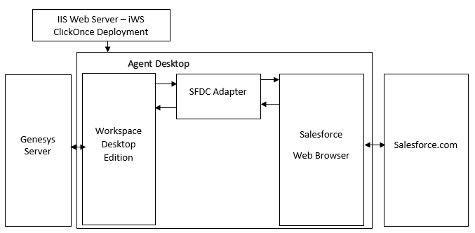

Figure . WDE-SFDC Integration diagram

### For Inbound Calls

1. On receiving call, WDE sends a request to the SFDC adapter.
2. To create the screen-pop
3. To make activity log entries
4. The SFDC Adapter sends a request to Salesforce to create a screen-pop.
5. The SFDC Adapter sends a request to Salesforce to do log activities.
6. SFDC brings up the appropriate screens on the Salesforce browser.
7. SFDC logs the activity in the SFDC database.
8. The SFDC Adapter creates automated records for custom objects.

### For Outbound Calls

1. Salesforce sends a request to the Adapter to dial out. SFDC passes the number to be dialed to the Adapter.
2. The SFDC Adapter passes the phone number to WDE to make an outbound call.
3. WDE dials the number (Outbound call).
4. WDE makes a request to the Adapter to make activity entries.
5. The Adapter sends a request to SFDC to make the log entries.
6. On Dialing Outbound from WDE, the Adapter creates screen pop-up and activity logs.

|  |  |
| --- | --- |
|  | **Note:** The SFDC Adapter will be installed as part of the WDE package on each agent’s desktop through ClickOnce. |

## Deployment

* 1. Copy the libraries below to the **Interaction Workspace**/**Workspace Desktop Edition** installed path.

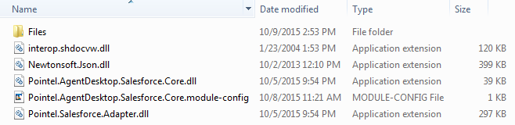

Figure . WDE-SFDC Integration library files

* 1. The lists of files available in the **Files** folder are below.

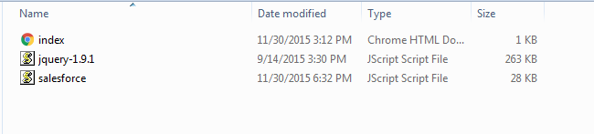

Figure . Files available in the Files folder

## Salesforce Configuration

The following configuration are relevant for configuring salesforce.

### Create a New Call Center

This section provides instructions on how to create a custom call center and console application to enable the adapter for screen pop integration. Perform the following steps to create a new Call Center (integrate Salesforce with Genesys CTI Systems).

* 1. Login into **Salesforce.com** and then click on the **Setup** link located in the right top corner.

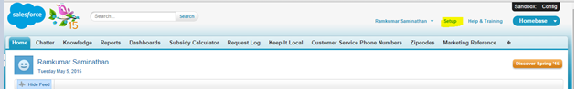

Figure . Setup

* 1. Click on **Customize** on the left hand side of the screen, select **Call Center** and then click on the **Call Centers** option.
  2. Now, click on **Continue** to import a new call center template.

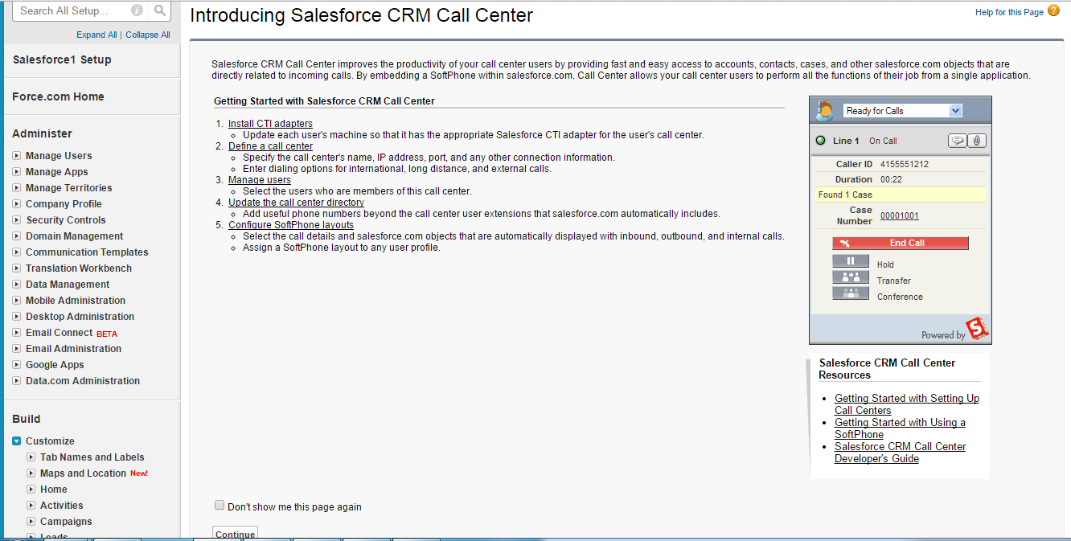

Figure . Salesforce CRM Call Center

* 1. Click the **Import** button.

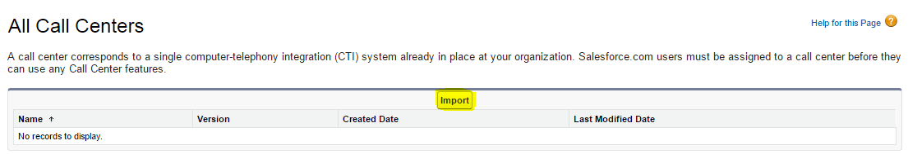

Figure . Import Button

* 1. Click on the **Choose File** button.

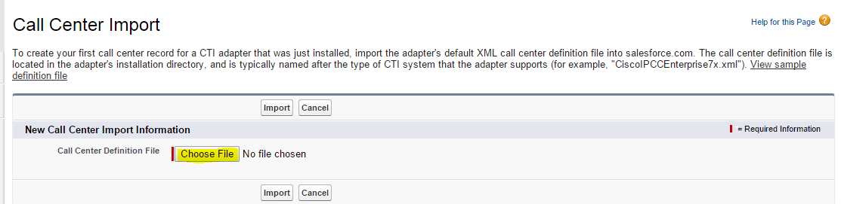

Figure . Call Center Import

* 1. Select the Call Center Template from your system location.

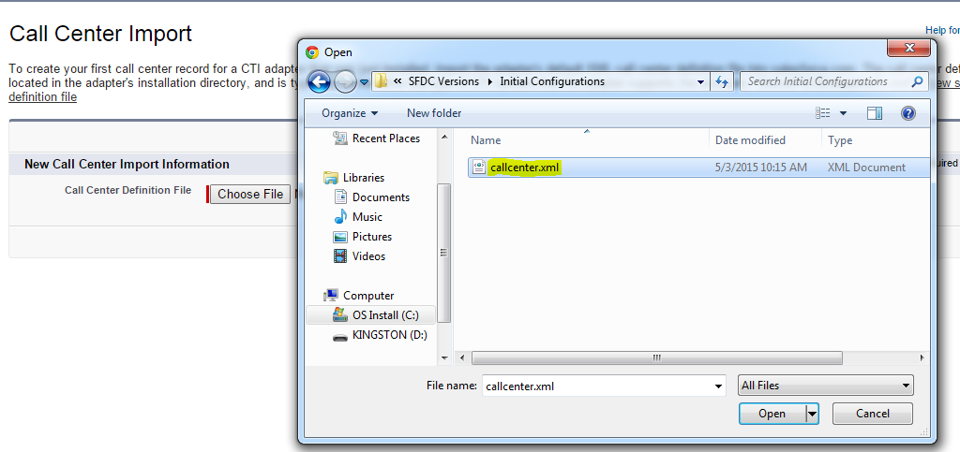

Figure . Open Dialog Box

* 1. Click on **Import** to finish the process.

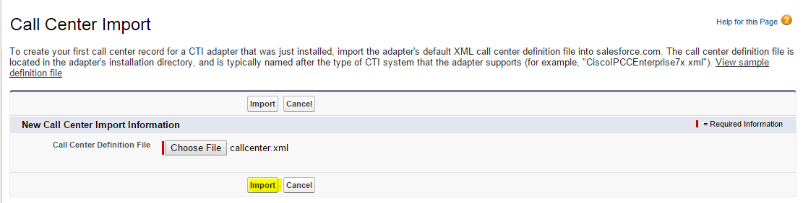

Figure . Import Button

* 1. Imported call center details are shown in the screenshot below.

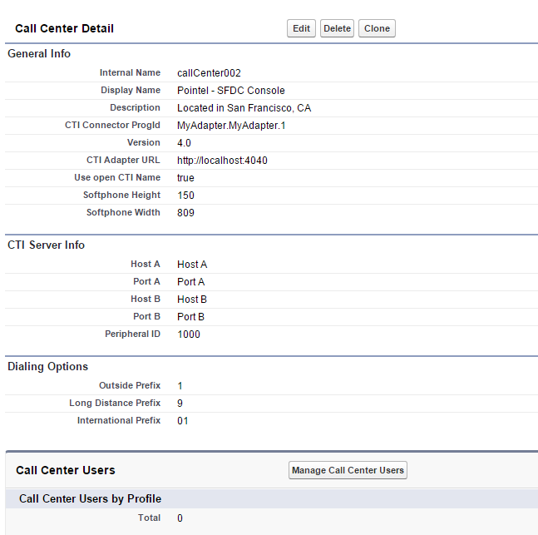

Figure . Imported Call Center Details

### Create Console App

The following steps explain how to create a console app in Salesforce.

1. On the left hand side of the page, under the **Build** section, click **Create** and then click **Apps**. Now, on the right side of the view, click on the **New** button for creating a new console app.

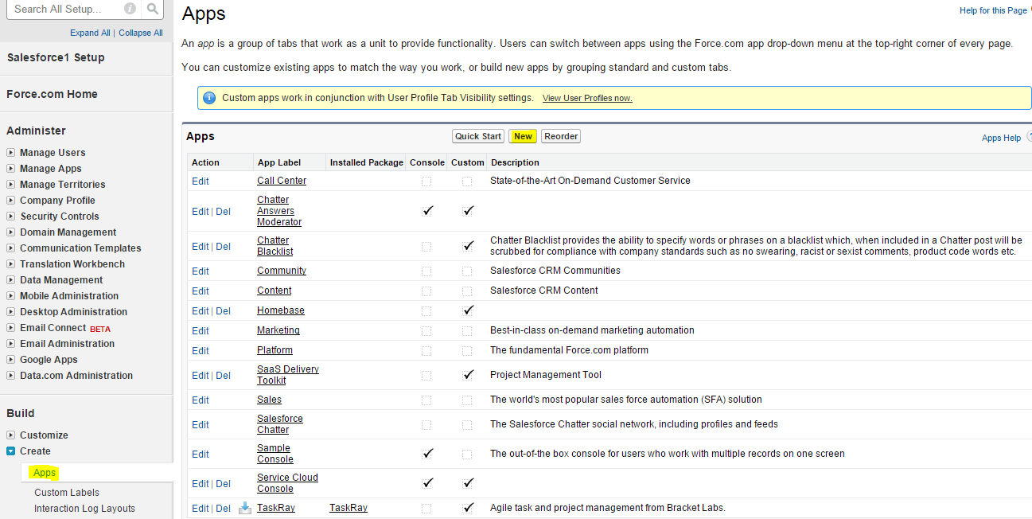

Figure . Console App

1. Choose **Console** as the type of app by enabling the radio button and then click on **Next** to continue the process.

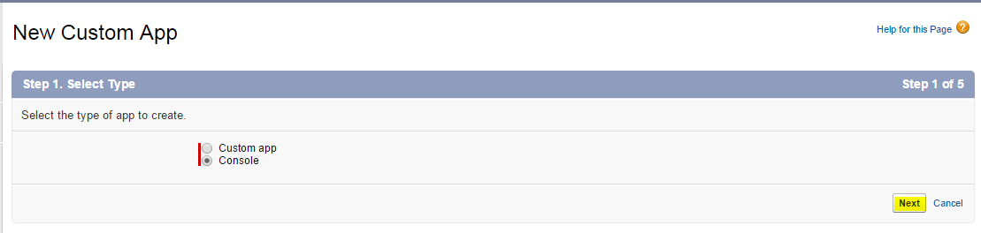

Figure . Select Console

1. Enter all required console information like **App** **Label**, **App** **Name,** **Description** and then click on the **Next** button.

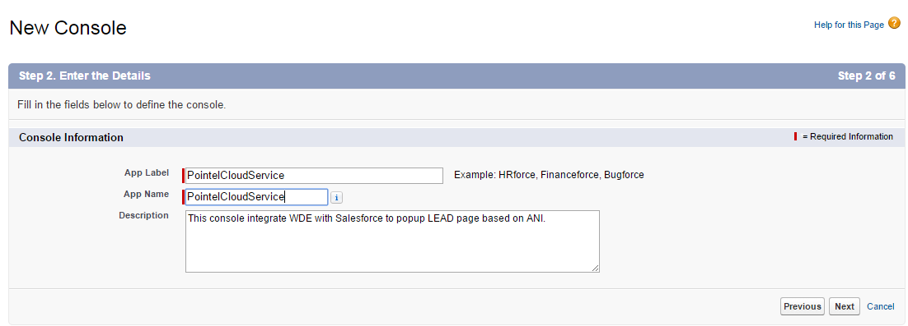

Figure . Console Details

1. Select a unique image required for the custom console.

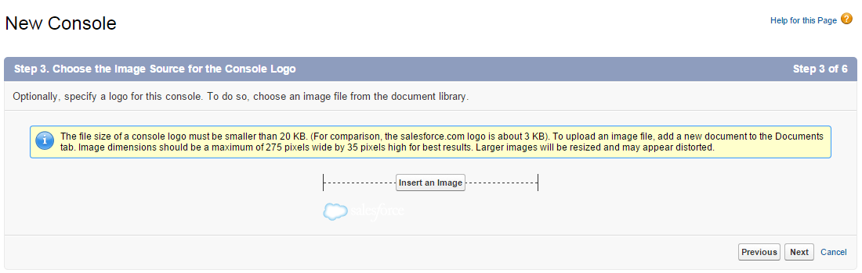

Figure . Console Logo

1. Choose the relevant items from the dropdown list shown in the figure below. The selected item will be included in the Salesforce navigation tab.

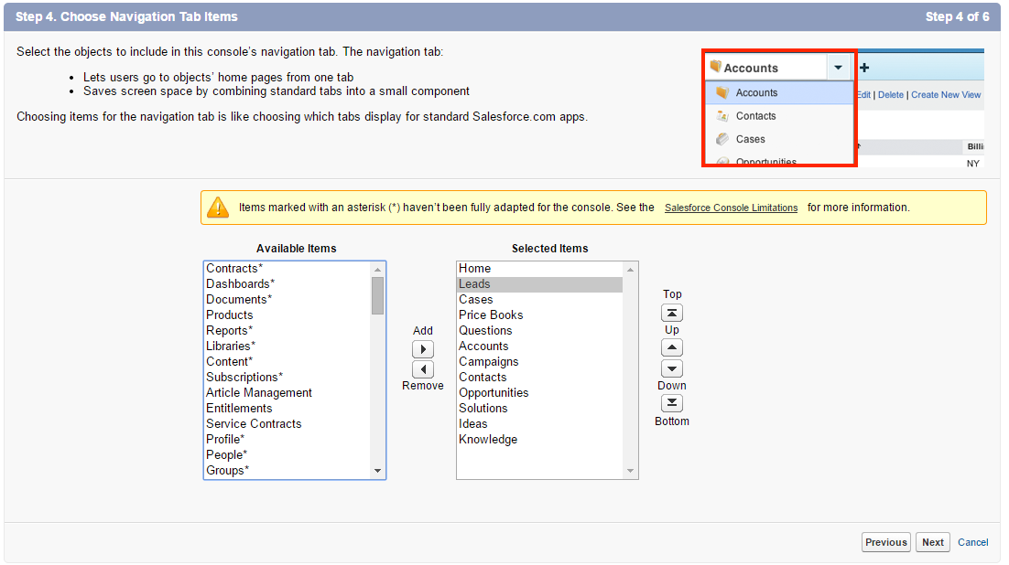

Figure . Accounts

1. Assign the new console app to a specific user group by enabling the checkbox. Once complete, this console app will be available to all users in the group.

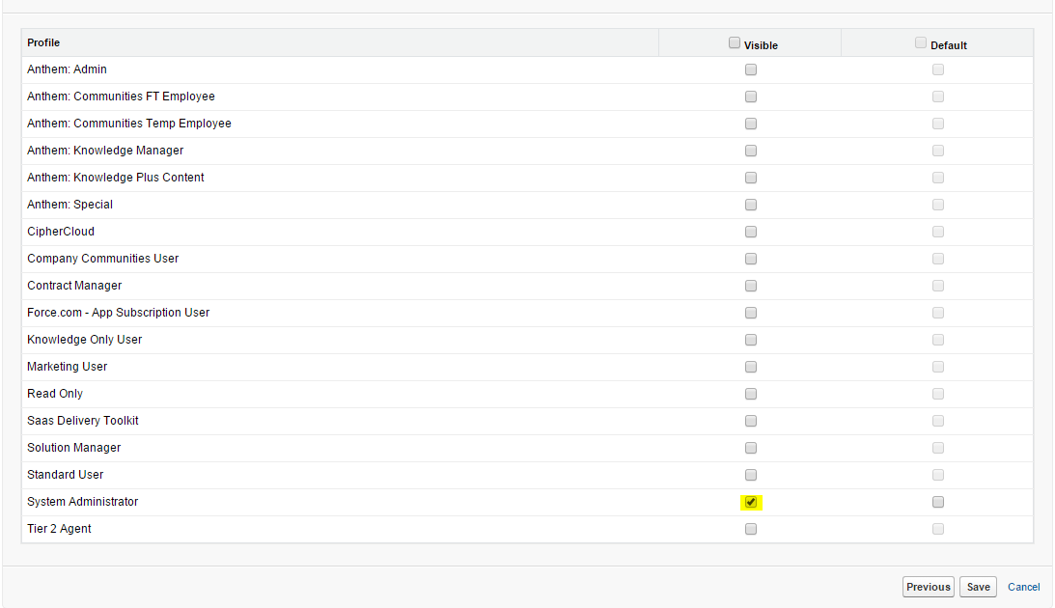

Figure . Assign Console to a Specific User Group

### Manage Users

The following section explains how to enable Salesforce users to have access to the custom console application and screen-pop.

Perform the following steps to enable access to the CTI integration.

1. On the main screen, select **Manage Users** from the left side menu under **Administrator** and choose the agent from the list.
2. Click on **Edit** from the selected User Profile.
3. Map the Center profile which is created as noted in **section 2.3.2** above (points 2-6).

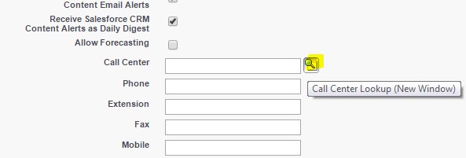

Figure . Call Center Lookup

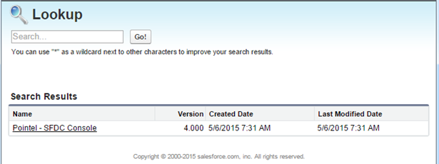

Figure . Lookup Screen

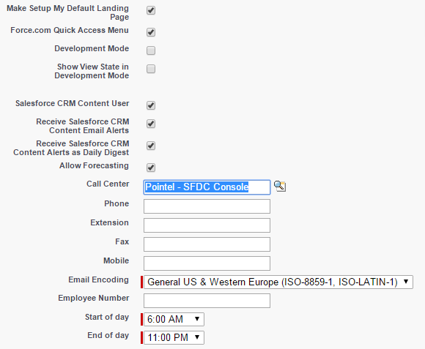

Figure . Created Call Center Profile

1. Enable **Service Cloud User.**

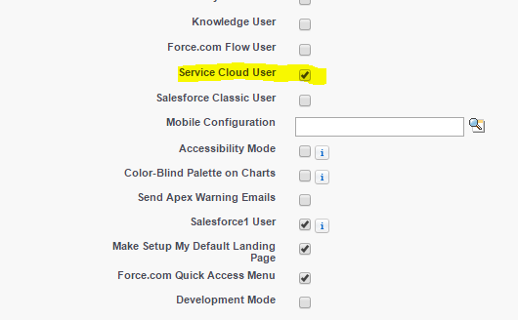

Figure . Enable Service Cloud Users

1. Note the Profile name and save the changes.

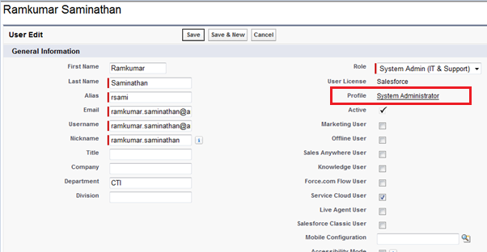

Figure . Verify Profile Name

### Profile Configuration

This section explains how to enable the custom console application to other profiles in Salesforce.

1. On the left side menu panel under the **Build** section, click on the **Apps** option under the **Create** menu.
2. Select the Custom Console application and click **Edit**.

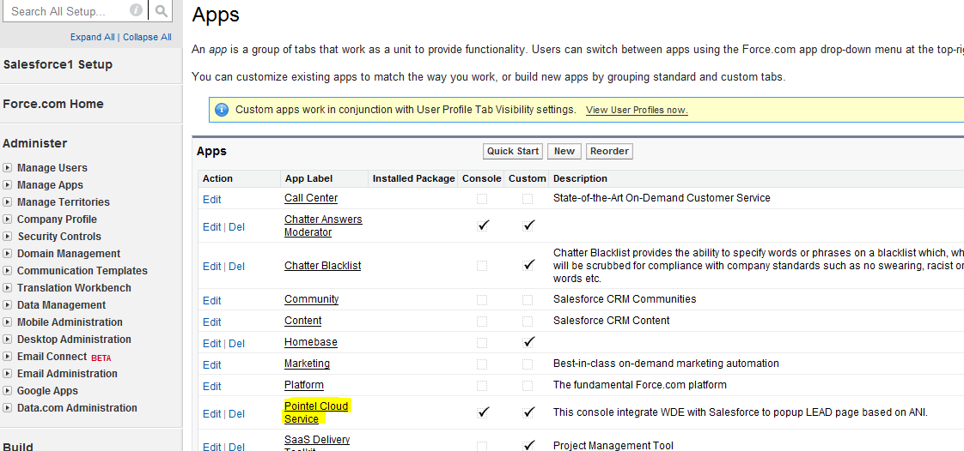

Figure . Custom Console Application

1. Select the applicable profile(s) for the group(s) of users which should have access to the Custom Console application.

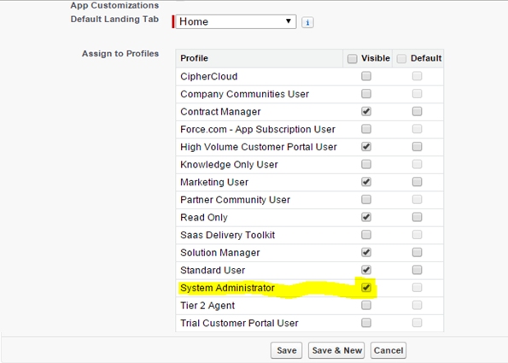

Figure . Configure Profile

1. After successful configuration, login to Salesforce with the user’s credentials and check for the console application access as shown below.

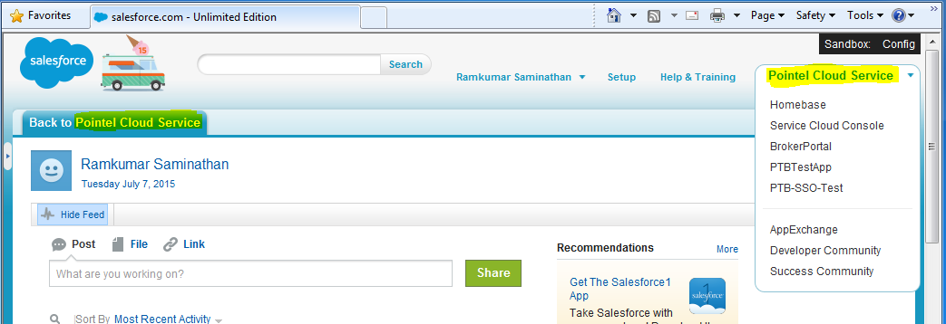

Figure . Configure Profile

1. Click on the **Back to Pointel Cloud Service** or **Pointel Cloud Service** option from the top right corner menu to get to the home page.

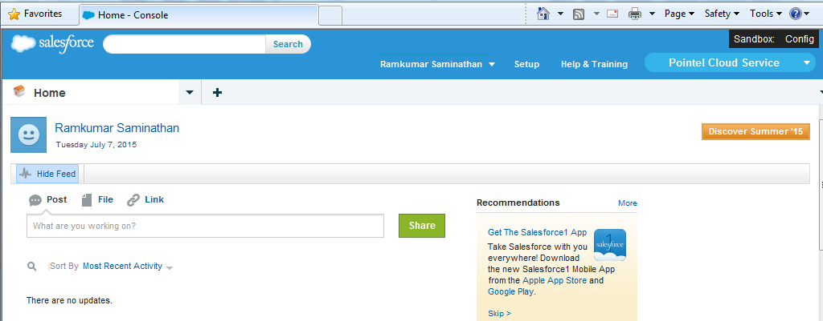

Figure . Configure Profile



# WDE – Salesforce Configuration

## WDE – Salesforce Configuration

This section provides the details of the Interaction Workspace/Workspace Desktop Edition configurations and integration with Salesforce.

There are three types of configurations in the SFDC Adapter:

1. Roles Privileges

* Enable/Disable the Salesforce integration with Workspace/Workspace Desktop Edition.

1. General Configuration

* All options must be configured under the section name **salesforce-integration**.
* This section contains all main features to enable the Salesforce integration and object popup for various scenarios.

1. Object Configuration

* All options must be configured individually in the new section of the annex tab (application, agent group and agent) for each object in Salesforce.

All of the options can be configured on the Application, an Agent Group and on a Person object in the Agent Annex. The description of each configuration option specifies to which object the option is applicable.

### Roles Privileges

The following role will enable/disable Interaction Workspace/Workspace Desktop Edition to integrate with Salesforce.

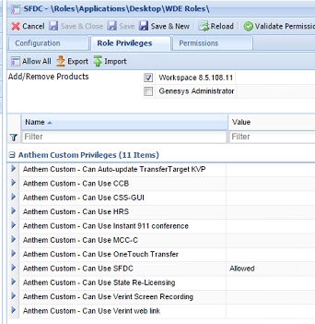

Figure . Genesys Administrator configurations

|  |  |
| --- | --- |
|  | **Note:** Follow WDE deployment document for enable/disable Roles Privileges. |

### General Configuration

The following steps explain how to configure Interaction Workspace/Workspace Desktop Edition to integrate with Salesforce.

The options below must be configured under the section name **salesforce-integration**.

|  |  |
| --- | --- |
| **Key Name** | sfdc.enable.integration |
| **Valid Values** | true/false |
| **Default Value** | true |

**Description**

This option specifies the enable/disable option for the Salesforce integration with Interaction Workspace/Workspace Desktop Edition at the Application, Agent Group and Agent level, even if this feature is enabled at Roles Privileges.

|  |  |
| --- | --- |
| **Key Name** | sfdc.browser-type |
| **Valid Values** | chrome/ie |
| **Default Value** | chrome |

**Description**

This option specifies the browser name that will be used. Based on the key, Salesforce will pop up in the appropriate browser. By default, Salesforce will pop up in the Google Chrome browser.

|  |  |
| --- | --- |
| **Key Name** | sfdc.enable.address-bar |
| **Valid Values** | true/false |
| **Default Value** | false |

**Description**

This option specifies the enable/disable option for displaying the address bar on the Salesforce popup browser.

|  |  |
| --- | --- |
|  | **Note:** This key is valid only with the **IE** browser and is not applicable for Chrome. |

|  |  |
| --- | --- |
| **Key Name** | sfdc.enable.status-bar |
| **Valid Values** | true/false |
| **Default Value** | false |

**Description**

This option specifies the enable/disable option for displaying the status bar on the Salesforce popup browser.

|  |  |
| --- | --- |
|  | **Note:** This key is valid only with the **IE** browser and is not applicable for Chrome. |

|  |  |
| --- | --- |
| **Key Name** | sfdc.integration.port |
| **Valid Values** | any valid port number |
| **Default Value** | - |

**Description**

This option specifies the port number for establishing communication between WDE and Salesforce. This configuration enables salesforce adapter to communicate with Salesforce to pop up the configured objects record and create activity history.

|  |  |
| --- | --- |
| **Key Name** | sfdc.adapter.listener-url |
| **Valid Values** | true/false |
| **Default Value** | false |

**Description**

The adapter will listen to the configured URL for communicating with Salesforce. Set “**true**” to enable this feature or “**false**” to disable.

|  |  |
| --- | --- |
| **Key Name** | sfdc.voice.enable.call-duration.from-wde |
| **Valid Values** | true/false |
| **Default Value** | false |

**Description**

This configuration key specifies whether or not to enable showing call duration in the application UI.

|  |  |
| --- | --- |
| **Key Name** | sfdc.display.connect-status |
| **Valid Values** | true/false |
| **Default Value** | false |

**Description**

This option specifies the enable/disable option to display the connection status between WDE and the SFDC Adapter.

|  |  |
| --- | --- |
| **Key Name** | sfdc.success.connect-message |
| **Valid Values** | Any String Value |
| **Default Value** | false |

**Description**

This option specifies the alert message to display in WDE when there is a successful connection between the SFDC Adapter and WDE.

|  |  |
| --- | --- |
| **Key Name** | sfdc.failure.connect-message |
| **Valid Values** | Any String Value |
| **Default Value** | false |

**Description**

This option specifies the alert message which will be displayed when there is a disconnection between the SFDC Adapter and WDE.

|  |  |
| --- | --- |
| **Key Name** | sfdc.login-url |
| **Valid Values** | valid Salesforce URL |
| **Default Value** | - |

**Description**

This option specifies the Salesforce login URL. WDE will pop up the configured URL after successful login.

|  |  |
| --- | --- |
| **Key Name** | sfdc.enable.popup.channel |
| **Valid Values** | voice, chat, email |
| **Default Value** | voice |

**Description**

This option specifies the different media names and enables the Adapter to pop-up Salesforce objects for the configured channel interaction.

|  |  |
| --- | --- |
| **Key Name** | sfdc.screen.popup |
| **Valid Values** | browser/iws |
| **Default Value** | browser |

**Description**

This option specifies the manner in which Salesforce will pop up. Based on the value, Salesforce will pop up inside iWS/WDE or outside of iWS/WDE (independent browser). The current version supports browser pop-up.

|  |  |
| --- | --- |
| **Key Name** | sfdc.popup.object-names |
| **Valid Values** | lead, account, contact, case, opportunity, customobject_i |
| **Default Value** | - |

**Description**

This option specifies which records will pop up for Salesforce objects based on the search condition. Object configurations should be in a unique section and in the Annex tab. Object configuration will be explained further in the Section 3.2.2. Here, **i** is the iteration and we can add any number of custom objects for record popup in Salesforce.

|  |  |
| --- | --- |
| **Key Name** | sfdc.popup-object.dialed.from.desktop-app |
| **Valid Values** | true/false |
| **Default Value** | false |

**Description**

This option specifies whether the Adapter creates a Salesforce object popup and activity log on dialing outbound from WDE.

|  |  |
| --- | --- |
| **Key Name** | sfdc.enable.consult-call |
| **Valid Values** | true/false |
| **Default Value** | false |

**Description**

This option specifies whether the Adapter dials a consult call when the agent is already on a call and a telephone number is dialed from Salesforce using the ClickToDial feature.

**Example:** Using the default value, if the agent clicks any phone number from Salesforce when he/she is already on a call, the Adapter will dial a consult call to that number based on this configuration.

|  |  |
| --- | --- |
| **Key Name** | sfdc.create.activity.business-attribute |
| **Valid Values** | valid business attribute name |
| **Default Value** | - |

**Description**

This option specifies the business attribute name. Configuring this option with a valid value will create activity history for the popup object record. Section 3.2 provides more details about configuring activity history.

|  |  |
| --- | --- |
|  | **Note: A**ctivity history will not be created if this option is not configured with a valid value. |

|  |  |
| --- | --- |
| **Key Name** | sfdc.new-record.business-attribute |
| **Valid Values** | Valid business attribute name |
| **Default Value** | - |

**Description**

This option specifies the business attribute name. Configuring this option with a valid value will create a new record for a configured object in Salesforce. Section 3.2 provides more details about configuring new records.

|  |  |
| --- | --- |
|  | **Note:** A new record will not be created if this option is configured with an invalid value. |

|  |  |
| --- | --- |
| **Key Name** | sfdc.voice.dial.outbound-call.on.not-ready |
| **Valid Values** | true/false |
| **Default Value** | false |

**Description**

This option specifies whether or not the agent is able to dial an outbound call from Salesforce using ClickToDial when he/she is in a not ready status.

|  |  |
| --- | --- |
| **Key Name** | sfdc.voice.out.prefix.dial-plan |
| **Valid Values** | Letters A to Z and a to z. Numbers 0 through 9. All special characters that are valid Windows file names |
| **Default Value** | - |

**Description**

This option defines the valid dial plan to make outbound calls from Salesforce. The value configured in this option will be prefixed to the phone number which is dialed from Salesforce.

|  |  |
| --- | --- |
| **Key Name** | sfdc.voice.con.prefix.dial-plan |
| **Valid Values** | Letters A to Z and a to z. Numbers 0 through 9. All special characters that are valid Windows file names |
| **Default Value** | - |

**Description**

This option defines the valid dial plan to make consult calls from Salesforce. The value configured in this option will be prefixed to the phone number which is dialed from Salesforce.

|  |  |
| --- | --- |
| **Key Name** | sfdc.enable.advanced-search |
| **Valid Values** | true/false |
| **Default Value** | false |

**Description**

This option specifies whether to use IWs with advanced search settings. By default, this option is set to false meaning that normal search operation is used for searching keywords.

|  |  |
| --- | --- |
| **Key Name** | sfdc.advanced-search.section-names |
| **Valid Values** | A valid section name for advanced search configs |
| **Default Value** | - |

**Description**

This option defines the valid section name for the advanced search configurations. The search configurations such as search field types, field names, object names, conditions, data length, etc., are configured.

|  |  |
| --- | --- |
| **Key Name** | search.field-type |
| **Valid Values** | all/phone/email/name/sidebar/custom |
| **Default Value** | all |

**Description**

This option defines the field type you want to search. For example, if you set default value as “phone” the adapter will search the keyword based on phone number. The filter setting will be disabled when the value is “Custom”.

|  |  |
| --- | --- |
| **Key Name** | search.field-names |
| **Valid Values** | MID,AccountNumber |
| **Default Value** | - |

**Description**

This option defines the search field names. The search keyword is assigned as values to both MID and account number for searching customer information. You can specify more than one field names with comma separated.

|  |  |
| --- | --- |
| **Key Name** | search.object-names |
| **Valid Values** | account,contact |
| **Default Value** | - |

**Description**

This option defines the search object names. Specify values with comma separated, where the search operation is carried out based on the specific object names.

|  |  |
| --- | --- |
| **Key Name** | search.data.condition |
| **Valid Values** | numeric/string/alphanumeric//customtext/none |
| **Default Value** | - |

**Description**

This option specifies the condition for searching the search keyword. The following is the description for each search condition.

* numeric – Search for data which is in numeric format.
* string – Search for data which is in string format.
* alphanumeric – Search for data which is in alphanumeric format.
* customtext – Search for data which is a custom text.
* none – Search all data that are matched with the search keyword.

|  |  |
| --- | --- |
| **Key Name** | search.condition.data.length |
| **Valid Values** | A valid integer value |
| **Default Value** | 0 |

**Description**

The Adapter will use this field to search an account object has a valid account object field configured. If the search value length is an eight digit number, the Adapter will only search account objects with the provided look up field.

|  |  |
| --- | --- |
| **Key Name** | search.delimiter |
| **Valid Values** | and/or |
| **Default Value** | or |

**Description**

This option defines the special operators for setting search conditions when more than one data are matched with the search.

* **AND**: The Adapter will search for records only if all search values match.
* **OR**: The Adapter will search for records if any one of the search values match.

|  |  |
| --- | --- |
| **Key Name** | search.enable.custom-query |
| **Valid Values** | true/false |
| **Default Value** | false |

**Description**

This configuration options specifies whether to enable custom query for adapter based search.

|  |  |
| --- | --- |
| **Key Name** | search.custom.query |
| **Valid Values** | Valid SOQL Query |
| **Default Value** | false |

**Description**

This configuration options defines the valid search query for adapter to searching data. For example: select id from contact where phone =**'searchdata\%**' here **'searchdata'** is taken from adapter based search configuration.

|  |  |
| --- | --- |
| **Key Name** | search.enable.response-filter |
| **Valid Values** | true/false |
| **Default Value** | false |

**Description**

This configuration options specifies whether to use filter feature. By default, this option is set to false meaning that filter option is disabled.

|  |  |
| --- | --- |
| **Key Name** | search.response-filter.field-names |
| **Valid Values** | A valid sfdc object field names |
| **Default Value** | - |

**Description**

The adapter will filter the search based on the configured field name.

|  |  |
| --- | --- |
| **Key Name** | search.data.skip-values |
| **Valid Values** | A comma separated values which adapter will skip search |
| **Default Value** | - |

**Description**

The adapter will skip search fields if the configured data is found.

## Configuring Salesforce – Voice Media Type

The section allows you to define the configurations relevant for customizing salesforce application towards voice media interactions.

### Enable/Disable Common Search Options

Configure the following options in the **salesforce-integration** section to enable common search keys to find records in Salesforce and perform a record popup.

|  |  |
| --- | --- |
| **Key Name** | sfdc.voice.enable.common.search |
| **Valid Values** | true/false |
| **Default Value** | false |

**Description**

This option specifies whether the Adapter will use common search keys or search keys from the object level. For example:

* If the Adapter is configured to popup 2 or more objects
* The search key is common to all objects

Enable this option and configure the following options in **salesforce-integration**. Now the Adapter will use a common search key to find records in all configured objects and provide a screen-pop accordingly.

* If the Adapter is configured to popup 2 or more objects
* A unique search key is configured for each object

Disable this option and do not configure following options in **salesforce-integration**. The Adapter will use the search key configured in each object and query Salesforce to perform a screen popup.

|  |  |
| --- | --- |
| **Key Name** | sfdc.voice.inb.popup-event-names |
| **Valid Values** | ringing, established, released |
| **Default Value** | -- |

**Description**

This option is used to configure the time when Salesforce objects will pop up.

* **ringing**: The Adapter will pop up Salesforce objects on the call ringing state. The agent will have the ability to view the customer information prior to answering the call.
* **established**: The Adapter will pop up Salesforce objects after a call is answered by an agent.
* **released**: The Adapter will pop up Salesforce objects after a call is released by an agent or the customer.

|  |  |
| --- | --- |
| **Key Name** | sfdc.voice.inb.search.user-data.key-names |
| **Valid Values** | Valid Key names from attach data separated by comma |
| **Default Value** | -- |

**Description**

This option will search records for inbound calls in Salesforce based on the values configured. This option accepts one or more search values separated by a comma.

|  |  |
| --- | --- |
| **Key Name** | sfdc.voice.inb.search.attribute.key-names |
| **Valid Values** | ani, thisdn, otherdn, connid, agentid, dnis |
| **Default Value** | -- |

**Description**

This option will search records for inbound calls in Salesforce based on the configured attribute keys. This option accepts one or more search values separated by a comma.

|  |  |
| --- | --- |
| **Key Name** | sfdc.voice.out.popup-event-names |
| **Valid Values** | dialing/established/released |
| **Default Value** | -- |

**Description**

This option is used to configure the time when Salesforce objects will pop up for **Outbound** calls.

* **dialing:** The Adapter will pop up Salesforce objects on the call dialing state. The agent will have the option to view the customer information prior to answering the call.
* **established:** The Adapter will pop up Salesforce objects after the call is answered by an agent.
* **released:** The Adapter will pop up Salesforce objects after the call is released by the agent or customer.

|  |  |
| --- | --- |
| **Key Name** | sfdc.voice.out.search.user-data.key-names |
| **Valid Values** | Valid Key names from attach data separated by comma |
| **Default Value** | -- |

**Description**

This option searches records in Salesforce for outbound calls based on the values of the configured attach data keys. This option accepts one or more search values separated by a comma.

|  |  |
| --- | --- |
| **Key Name** | sfdc.voice.out.search.attribute.key-names |
| **Valid Values** | ani, thisdn, otherdn, connid, agentid, dnis |
| **Default Value** | -- |

**Description**

This option searches records in Salesforce for outbound calls based on the configured attribute keys. This option accepts one or more search values separated by a comma.

|  |  |
| --- | --- |
| **Key Name** | sfdc.voice.con.popup-event-names |
| **Valid Values** | ringing/established/released |
| **Default Value** | -- |

**Description**

This option is used to configure the time when Salesforce objects pop up for Consult calls.

* **ringing**: The Adapter will pop up Salesforce objects on call ringing state. The agent will have the option to view the customer information before answering the call.
* **established**: The Adapter will pop up Salesforce objects after the call is answered by the agent.
* **released**: The Adapter will pop up Salesforce objects after the call is released by the agent or customer.

|  |  |
| --- | --- |
| **Key Name** | sfdc.voice.con.search.user-data.key-names |
| **Valid Values** | Valid key name from attach data separated by comma |
| **Default Value** | -- |

**Description**

This option searches records in Salesforce based on the value of the configured attach data key, pops up on the second agent’s screen (agent who received the consult call) and writes an activity log (collects data from the inbound call configuration in the business attribute).

|  |  |
| --- | --- |
| **Key Name** | sfdc.voice.con.search.attribute.key-names |
| **Valid Values** | ani, thisdn, otherdn, connid, agentid, dnis |
| **Default Value** | -- |

**Description**

This option searches records in Salesforce based on the value from the configured attach data key, pops up on the second agent’s screen (agent who received the consult call) and writes an activity log (collects data from the inbound call configuration in the business attribute).

|  |  |
| --- | --- |
| **Key Name** | sfdc.voice.search.priority |
| **Valid Values** | user-data/attribute/both |
| **Default Value** | -- |

**Description**

This option specifies the search priority for voice record popups. Based on the configuration, the Adapter will read search values from the appropriate options.

|  |  |
| --- | --- |
| **Key Name** | sfdc.voice.search.condition-type |
| **Valid Values** | AND/OR |
| **Default Value** | OR |

**Description**

This option specifies the search condition type when more than one search data type has been configured.

* **AND**: The Adapter will search for records only if all search values match.
* **OR**: The Adapter will search for records if any one of the search values match.

|  |  |
| --- | --- |
| **Key Name** | sfdc.voice.search.phone-number.format |
| **Valid Values** | valid phone number format |
| **Default Value** | -- |

**Description**

The Adapter will search records in Salesforce using the configured search format if no records are found in the search without applying any format. This option accepts more than one value separated by comma.

**Ex. sfdc.voice.search.phone-number.format= (xxx) xxx-xxxx**

First, the Adapter will search records using the search data as it is. If no records are found, then it will apply the configured formats with the search data and perform the search again. The Soap API response time will vary based on the number of formats that will be searched.

|  |  |
| --- | --- |
|  | **Note:**  Use character 'x' to denote phone number digit and use any delimiter between numbers  e.g : xxx-xxx-xxxx  (xxx)-xxx-xxxx  (xxx) xxx-xxxx  (xxx)xxxxxxx  If a format is not configured for this option, the above formats will be applied by default.  Each format takes a reasonable amount of time to get a response from the Salesforce server based on the server ability. |

|  |  |
| --- | --- |
| **Key Name** | sfdc.chrome.browser-command |
| **Valid Values** | valid chrome flag |
| **Default Value** | --unsafely-treat-insecure-origin-as-secure=http://localhost:<Value of “sfdc.integration.port”> --test-type --user-data-dir= |

**Description**

The Adapter will use this command to open a Chrome browser if **sfdc.screen.popup** is set as “**browser**” and **sfdc.browser-type** is set as “**chrome**”.

**Ex. sfdc.chrome.browser-command= --unsafely-treat-insecure-origin-as-secure=http://localhost:4040 --test-type --user-data-dir=**

|  |  |
| --- | --- |
| **Key Name** | sfdc.chrome.browser.temp-directory |
| **Valid Values** | valid directory path |
| **Default Value** | %AppData%\Genesys Telecommunication\InteractionWorkspace\Temp_Chrome |

**Description**

The Adapter will use this directory for the Chrome browser as a user data directory. If the directory does not exist it will create the directory as configured. **Ex.sfdc.chrome.browser.temp-directory=C:\ChromeTempFolder**

|  |  |
| --- | --- |
| **Key Name** | sfdc.account.lookup-field |
| **Valid Values** | valid account object field |
| **Default Value** | - |

**Description**

The Adapter will use this field to search an account object if **sfdc.popup.object-names** has a valid account object field configured. If the search value length is an eight digit number, the Adapter will only search account objects with the provided look up field.

|  |  |
| --- | --- |
| **Key Name** | sfdc.soap.service-url |
| **Valid Values** | valid soap service url |
| **Default Value** | - |

**Description**

The Adapter will use this service URL for Salesforce API operations.

**Ex. sfdc.chrome.browser.temp-directory= https://test.salesforce.com/services/Soap/u/35.0**

|  |  |
| --- | --- |
| **Key Name** | sfdc.soap.api.enable.error-message |
| **Valid Values** | true/false |
| **Default Value** | false |

**Description**

Based on this option, the Adapter will display Soap API call exceptions in the WDE toaster popup window.

**Ex. sfdc.soap.api.enable.error-message= true**

|  |  |
| --- | --- |
| **Key Name** | sfdc.user.time-zone |
| **Valid Values** | Valid Time Zone(GMT-08:00)/GMTZ/GMTAPEX |
| **Default Value** | GMTZ |

**Description**

This option specifies the current user time zone in Salesforce and enables the Adapter to create activity logs or records with a valid user time zone. **Ex: sfdc.user.time-zone = GMT-08:00**

The above value specifies the time zone (GMT-08:00) which should be available in Salesforce. **Ex. sfdc.user.time-zone = GMTZ**

The above value specifies the default time zone. The Adapter will use the current agent machine time zone for creating records in Salesforce. **Ex. sfdc.user.time-zone = GMTAPEX**

The above configuration requires the Adapter to use the current user time zone from Salesforce and create records using the same.

|  |  |
| --- | --- |
| **Key Name** | sfdc.enable.connect-status.view |
| **Valid Values** | true/false |
| **Default Value** | true |

**Description**

This option enables the Adapter to display the connection status of the Salesforce Adapter and WDE on the WDE toolbar window.

|  |  |
| --- | --- |
| **Key Name** | sfdc.enable.notify.all.state.change |
| **Valid Values** | true/false |
| **Default Value** | true |

**Description**

This option enables the Adapter to provide the connection status on the WDE tool bar whenever it is changed.

|  |  |
| --- | --- |
| **Key Name** | sfdc.adapter-wde.status-message |
| **Valid Values** | Valid string message |
| **Default Value** | -- |

**Description**

This option specifies the message to be displayed regarding the connection status in the WDE toolbar window. **Ex:sfdc.adapter-wde.status-message=Salesforce Connection State**

|  |  |
| --- | --- |
| **Key Name** | sfdc.adapter-wde.status-connect.color |
| **Valid Values** | Valid Color |
| **Default Value** | #2DB143 |

**Description**

This option specifies the color to be displayed when Salesforce is in a connected state.

**Ex: sfdc.adapter-wde.status-connect.color = Green**

|  |  |
| --- | --- |
| **Key Name** | sfdc.adapter-wde.status-disconnect.color |
| **Valid Values** | Valid Color |
| **Default Value** | #E81100 |

**Description**

This option specifies the color to be displayed when Salesforce is in a disconnected state.

**Ex:sfdc.adapter-wde.status-disconnect.color=Red**

|  |  |
| --- | --- |
| **Key Name** | sfdc.enable.notify.disconnect.status.on.call |
| **Valid Values** | true/false |
| **Default Value** | false |

**Description**

This option specifies whether or not the Adapter will display an alert message when an inbound call reaches an agent and SFDC is not connected.

**Ex: sfdc.enable.notify.disconnect.status.on.call=true**

|  |  |
| --- | --- |
| **Key Name** | sfdc.close-browser.on.wde-close |
| **Valid Values** | true/false |
| **Default Value** | true |

**Description**

The Adapter prevents the Salesforce browser (launched by WDE) from closing after closing WDE.

**Ex:** sfdc.close-browser.on.wde-close **=true**

WDE will close the Salesforce browser (launched by WDE) after closing WDE.

sfdc.close-browser.on.wde-close **=false**

WDE will not close the Salesforce browser (launched by WDE) after closing WDE.

|  |  |
| --- | --- |
| **Key Name** | sfdc.browser.instance-notification.message |
| **Valid Values** | Valid string message |
| **Default Value** | Browser open – SFDC Login required |

**Description**

The Adapter will display the configured message when there is a disconnection between the Adapter and WDE and the agent clicks on the status button on the WDE toolbar multiple times.

Ex: The agent will receive the configured message in the scenario below.

* Login to WDE and Salesforce through the browser opened by WDE.
* Before logging into Salesforce, WDE will display the status in “Red”. If the agent clicks on the “Red” status button, WDE will display the following configured message.

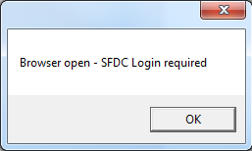

The purpose of this message is to let the agent know that WDE will not pop up multiple browsers and the agent is required to login to Salesforce from the browser opened by WDE.

|  |  |
| --- | --- |
| **Key Name** | sfdc.enable.browser.instance-notification |
| **Valid Values** | true/false |
| **Default Value** | true |

**Description**

This option will prevent a notification message from being displayed when there is a disconnection between the Adapter and WDE and the agent clicks on the status button on the WDE toolbar multiple times.

|  |  |
| --- | --- |
| **Key Name** | sfdc.common-search.multi-match.behavior |
| **Valid Values** | search/match-record/none |
| **Default Value** | none |

**Description**

This option is used to control the record search and popup when common search is enabled.

* **search**: The adapter will popup search page with the result of current search data when more than one record found.
* **Match-record**: The Adapter will pop up single record from any one of common search objects, if only one record found for the search data.
* **none**: The Adapter will pop up records based on object specific configuration of different objects.

|  |  |
| --- | --- |
| **Key Name** | sfdc.common-search.multi-match.behaviour.enable.profile-activity.popup |
| **Valid Values** | true/false |
| **Default Value** | false |

**Description**

This option is used to enable/disable popup of profile level activity which is created on multiple-match found on common search.

|  |  |
| --- | --- |
| **Key Name** | sfdc.enable.force-acw |
| **Valid Values** | true/false |
| **Default Value** | false |

**Description**

This option is used to enable/disable voice auto aftercallwork status after the call is answered and Disposition Code Model window popup after the call is ended.

|  |  |
| --- | --- |
| **Key Name** | sfdc.enable.mandatory.mark-done |
| **Valid Values** | true/false |
| **Default Value** | false |

**Description**

This option is used to enable/ disable mandatory disposition code for inbound/ outbound/ Consult interactions. This option will not apply to internal calls.

|  |  |
| --- | --- |
| **Key Name** | sfdc.enable.force-acw.mark-done |
| **Valid Values** | true/false |
| **Default Value** | false |

**Description**

This option is used to enable/ disable auto mark-done for inbound/ outbound/ consult interactions after disposition code model window closed.

|  |  |
| --- | --- |
| **Key Name** | sfdc.voice.consult.add.attach-data.key-name |
| **Valid Values** | Any string key |
| **Default Value** | IsTransferedCall |

**Description**

This option is used to attach a KVP with current inbound/ outbound interaction user data and consulted party can use to create activity log

**(E.x): sfdc.voice.consult.add.attach-data.key-name = sfdc_consult_type**

This key will hold the value of either “sfdc.voice.con.init.calltype.text”,

or “sfdc.voice.con.complete.calltype.text” keys based on the single step or two-step consultation dialed.

|  |  |
| --- | --- |
| **Key Name** | sfdc.voice.con.init.calltype.text |
| **Valid Values** | Any string text |
| **Default Value** | Inbound-Consult |

**Description**

This option will hold the text which is used to attach with consult call when First agent initiating a consult call to second agent. **(E.X): sfdc.voice.con.init.calltype.text = Internal-Consult**

|  |  |
| --- | --- |
| **Key Name** | sfdc.voice.con.complete.calltype.text |
| **Valid Values** | Any string text |
| **Default Value** | Inbound-Transfer |

**Description**

This option will hold the text which is used to attach with consult call when First agent completing a consult call with second agent or making single-step transfer/conference.

(i.g): **sfdc.voice.con.complete.calltype.text= Internal-Transfer**

|  |  |
| --- | --- |
| **Key Name** | sfdc.voice.consult.attach.response-id.key-name |
| **Valid Values** | Any string text |
| **Default Value** | sfdc_response_id |

**Description**

This option will hold the key name which is used to attach with consult call with sfdc response id.

(i.g): **sfdc.voice.consult.attach.response-id.key-name= sfdc_response_id**

|  |  |
| --- | --- |
| **Key Name** | sfdc.voice.attach.out.attach.dialed-number |
| **Valid Values** | Any string text |
| **Default Value** | sfdc_dialed_number |

**Description**

This option will hold the key name which is used to attach with consult call with phone number of inbound/ outbound call.

(i.g):**sfdc.voice.attach.out.attach.dialed-number= ScreenPOP_Key**

|  |  |
| --- | --- |
| **Key Name** | sfdc.tls.version |
| **Valid Values** | 1.1/1.2/1.1,1.2/none |
| **Default Value** | 1.0 |

**Description**

This option specifies the security protocol version number for establishing connection with salesforce. If this option not set then default version 1.0 will be set.

### Object Configuration

This section explains the options for Salesforce object level configuration. Each Salesforce object is configured in a unique section in annex tab. An administrator can configure different search keys and popup behavior for each object.

|  |  |
| --- | --- |
|  | **Note:**  Create a section in the Annex tab using a Salesforce object name.  Ex: lead, account, contact, opportunity  To configure a custom object configure the section as shown below  EX: customobject_1 |

|  |  |
| --- | --- |
| **Key Name** | object-name |
| **Valid Values** | valid sfdc object name |
| **Default Value** | -- |

**Description**

Configure any valid Salesforce object name. The Adapter will pop the configured Salesforce object and create/update the activity log. **Ex. object-name = Lead**

Lead is a valid SFDC object name and it will be used for search records and create activity logs in apex classes. **Ex. Object-name = CustomLead__c**

Custom objects must be configured with a valid custom object name (API Name) so that records will be popped up and activity logs created.

|  |  |
| --- | --- |
| **Key Name** | object.url-id |
| **Valid Values** | valid custom object URL ID |
| **Default Value** | -- |

**Description**

Configure a valid URL ID of the custom Salesforce object. This option must be configured in order for the Adapter to popup the appropriate custom Salesforce object.

**Section 4.1.5** will explain the details of obtaining a Salesforce custom object URL ID.

|  |  |
| --- | --- |
|  | **Note:** This key is only valid for custom object pop-ups and is not needed for default SFDC objects. |

**Ex. object.url.id = a02**

The following keys must be configured to pop-up records for Voice Calls in Salesforce.

|  |  |
| --- | --- |
| **Key Name** | voice.max-record.open |
| **Valid Values** | 1 to 50 |
| **Default Value** | 5 |

**Description**

This option is used to set a limit for opening multiple match records for a given search condition. This option will be activated when the option **voice.inb.search.multi-match=openall** or

**voice.out.search.multi-match=openall** is set.

|  |  |
| --- | --- |
| **Key Name** | voice.new-record.field-id |
| **Valid Values** | Valid field ID’s from Salesforce object |
| **Default Value** | -- |

**Description**

This option prepopulates search values on Salesforce objects. This option should be configured when the option “voice.inb.search.no-record” or “voice.out.search.no-record” value is set to “opennew”. **Section 4.1.5** will explain the details of finding the field ID details from the Salesforce object.

|  |  |
| --- | --- |
| **Key Name** | voice.search.priority |
| **Valid Values** | user-data/attribute/both |
| **Default Value** | user-data |

**Description**

This option specifies the search priority for voice popup. Based on the configuration, the Adapter will get a search value from salesforce adapter.

* **user-data**: The Adapter will take search values configured in **voice.<call-type>.search.user-data.key-names**.
* **attribute**: The Adapter will take search values configured in **voice.<call-type>.search.attribute.key-names**.
* **both**: The Adapter will take search values configured in both **voice.<call-type>.search.user-data.key-names** and **voice.<call-type>.search.attribute.key-names**.

|  |  |
| --- | --- |
| **Key Name** | voice.search.condition-type |
| **Valid Values** | and/or |
| **Default Value** | or |

**Description**

This option specifies the search condition type.

* **and**: The Adapter will search for records only if all search values match.
* **or**: The Adapter will search for records if any one search value matches.

|  |  |
| --- | --- |
| **Key Name** | voice.search.phone-number.format |
| **Valid Values** | valid phone number format |
| **Default Value** | xxx-xxx-xxxx  (xxx)-xxx-xxxx  (xxx) xxx-xxxx  (xxx)xxxxxxx |

**Description**

The Adapter will search records in Salesforce using the configured search format. When no record is found, the search will follow the other configured search formats. This option accepts more than one value separated by comma.

**Ex. voice.search.phone-number.format= xxx-xxx-xxxx**

First, the Adapter will search records using search data as it is, if no record is found then it will apply the configured formats with search data and will perform the search again.

|  |  |
| --- | --- |
|  | **Note:** Use ‘x’ to denote phone number digits and use any delimiter between the numbers.  e.g : xxx-xxx-xxxx  (xxx)-xxx-xxxx  (xxx) xxx-xxxx  (xxx)xxxxxxx  If a format is not configured for this option, the above formats will be applied by default.  Each format takes reasonable time to get a response from the Salesforce server based on the server ability. |

### Inbound Call Configuration

|  |  |
| --- | --- |
| **Key Name** | voice.inb.search.user-data.key-names |
| **Valid Values** | Valid Key names from attach data separated by comma |
| **Default Value** | -- |

**Description**

The Adapter searches records for inbound calls in Salesforce based on the values from the configured attach data keys. This option accepts one or more search values separated by a comma.

|  |  |
| --- | --- |
| **Key Name** | voice.inb.search.attribute.key-names |
| **Valid Values** | ani, thisdn, otherdn, connid, agentid, dnis |
| **Default Value** | -- |

**Description**

The Adapter searches records for inbound calls in Salesforce based on the configured attribute keys. This option accepts one or more search values separated by a comma.

|  |  |
| --- | --- |
| **Key Name** | voice.inb.popup-event-names |
| **Valid Values** | ringing/established/released |
| **Default Value** | -- |

**Description**

Based on the value configured, Salesforce will pop up an appropriate voice event.

* **ringing**: The Adapter will popup Salesforce objects on the call ringing state. The agent will have an option to view the customer information prior to answering the call.
* **established**: The Adapter will popup Salesforce objects after the call is answered by the agent.
* **released**: The Adapter will popup Salesforce objects after the call is released by the agent or customer.

|  |  |
| --- | --- |
| **Key Name** | voice.inb.create.activity-log |
| **Valid Values** | true/false |
| **Default Value** | true |

**Description**

This option determines whether or not the Salesforce Adapter will create activity logs for inbound record pop ups.

|  |  |
| --- | --- |
| **Key Name** | voice.inb.update.activity-log |
| **Valid Values** | true/false |
| **Default Value** | false |

**Description**

This option determines whether or not the Salesforce Adapter will update activity logs for inbound record pop ups.

|  |  |
| --- | --- |
| **Key Name** | voice.inb.update.activity-log.event-names |
| **Valid Values** | released,datachanged,rejected |
| **Default Value** | -- |

**Description**

Based on this configuration, Salesforce will update activity logs and record data on an appropriate voice event for inbound call. This option accepts multiple events configurations separated by comma.

* **released:** The Adapter updates the activity logs and new records in a call released event for inbound calls.
* **datachanged:** The Adapter updates the activity logs and new records in call Disposition code changed events for inbound calls.
* **rejected:** The Adapter updates the activity logs and new records when an inbound call is rejected.

|  |  |
| --- | --- |
| **Key Name** | voice.inb.search.no-record |
| **Valid Values** | opennew/createnew/searchpage/none |
| **Default Value** | opennew |

**Description**

This option specifies the action to be taken when no record found for given **inbound** call search condition. By default the option value is **opennew**.

* **opennew**: Configuring this value will open new record with search data pre-populated on appropriate fields based on the value configured in the option **voice.new-record.field-id**.
* **searchpage**: Configuring this value will opens the search page based on the value configured in the option **voice.multi-match.records.searchpage** configuration.
* **createnew**: Configuring this value will create new record with data. New record data fields should be configured in **sfdc.new-record.business-attribute** option.
* **none**: No action will happen when it is configured as none.

|  |  |
| --- | --- |
| **Key Name** | voice.inb.search.multi-match |
| **Valid Values** | searchpage/openall/none |
| **Default Value** | searchpage |

**Description**

This option specifies the action to be taken when multiple records found for given **inbound** call search condition.

* **openall**: Configuring this value will open all records found for given search condition. Opening all records can be controlled by the option **voice.max-record.open**. If **voice.max-record.open** option is not configured adapter will take default value 50.
* **searchpage**: Configuring this value will list all records found for given search condition in search page.
* **none**: Configuring this value will not do any action for given search condition.

|  |  |
| --- | --- |
| **Key Name** | voice.inb.search.enable.profile-activity |
| **Valid Values** | true/false |
| **Default Value** | false |

**Description**

This option specifies whether to create profile level activity log when multi-match scenario found for inbound call. If Common Search enabled then adapter will use **“sfdc.profile-activity.business-attribute”** configuration to create activity log and if object based search enabled then adapter takes “**sfdc.create.activity.business-attribute”** configuration for creating log.

|  |  |
| --- | --- |
| **Key Name** | voice.inb.search.popup.profile-activity |
| **Valid Values** | true/false |
| **Default Value** | false |

**Description**

This option specifies whether to popup user profile activity log which is created on multiple match record found scenario on inbound call.

|  |  |
| --- | --- |
| **Key Name** | voice.inb.search.no-record.enable.profile-activity |
| **Valid Values** | true/false |
| **Default Value** | false |

**Description**

This option specifies whether to create profile level activity log when no-match found scenario and no-match action is set to **“opennew”** for inbound call. If Common Search enabled then adapter will use **“sfdc.profile-activity.business-attribute”** configuration to create activity log and if object based search enabled then adapter takes “**sfdc.create.activity.business-attribute”** configuration for creating log.

|  |  |
| --- | --- |
| **Key Name** | voice.inb.search.no-record.none.activity-log |
| **Valid Values** | true/false |
| **Default Value** | false |

**Description**

This option specifies whether to create profile level activity log when no-match found scenario and no-match action is set to **“none”** for inbound call. If Common Search enabled then adapter will use **“sfdc.profile-activity.business-attribute”** configuration to create activity log and if object based search enabled then adapter takes “**sfdc.create.activity.business-attribute”** configuration for creating log.

|  |  |
| --- | --- |
| **Key Name** | voice.inb.search.no-record.popup.profile-activity |
| **Valid Values** | true/false |
| **Default Value** | false |

**Description**

This option specifies whether to popup user profile activity log which is created on no -match found scenario on inbound call.

### Outbound Call Configuration

|  |  |
| --- | --- |
| **Key Name** | voice.out.search.user-data.key-names |
| **Valid Values** | Valid Key names from attach data separated by comma |
| **Default Value** | - |

**Description**

The Adapter will search records in Salesforce for outbound calls based on the values from the configured attach data keys. This option accepts one or more search values separated by a comma.

|  |  |
| --- | --- |
| **Key Name** | voice.out.search.attribute.key-names |
| **Valid Values** | ani, thisdn, otherdn, connid, agentid, dnis |
| **Default Value** | Otherdn |

**Description**

The Adapter searches records in Salesforce for outbound calls based on the configured attribute keys. This option accepts one or more search values separated by a comma.

|  |  |
| --- | --- |
| **Key Name** | voice.out.popup-event-names |
| **Valid Values** | dialing/established/released |
| **Default Value** | - |

**Description**

This option is used to specify when to popup Salesforce objects for outbound calls.

* **dialing**: The Adapter will popup Salesforce objects in the call dialing state. The Agent will have the option to view the customer information prior to answering the call.
* **established**: The Adapter will popup Salesforce objects after the call is answered by the agent.
* **released**: The Adapter will popup Salesforce objects after the call is released by the agent or customer.

|  |  |
| --- | --- |
| **Key Name** | voice.out.success.create.activity-log |
| **Valid Values** | true/false |
| **Default Value** | true |

**Description**

This option specifies whether or not the Salesforce Adapter will create an activity log for outbound records pop up.

|  |  |
| --- | --- |
| **Key Name** | voice.out.success.update.activity-log |
| **Valid Values** | true/false |
| **Default Value** | false |

**Description**

This option specifies whether or not the Salesforce Adapter will update activity logs for outbound records pop up.

|  |  |
| --- | --- |
| **Key Name** | voice.out.success.update.activity-log.event-names |
| **Valid Values** | released, datachanged |
| **Default Value** | - |

**Description**

Based on the value configured, the Salesforce Adapter will update activity logs/custom object record data during an appropriate voice event. More than one events configuration can be configured if separated by comma.

|  |  |
| --- | --- |
| **Key Name** | voice.out.fail.create.activity-log |
| **Valid Values** | true/false |
| **Default Value** | true |

**Description**

This option specifies whether or not the Salesforce Adapter will create an activity log for outbound call failure record pop ups.

|  |  |
| --- | --- |
| **Key Name** | voice.out.fail.create.activity-log.event-names |
| **Valid Values** | busy,not reachable,error |
| **Default Value** |  |

**Description**

Based on the event names configured, Salesforce will pop up a record and create an activity log for the outbound failure scenario.

* **busy**: The Adapter will pop up and create an activity log when the agent receives a busy response from the customer.
* **not** **reachable**: The Adapter will pop up and create an activity log when the agent is not able to reach the customer.
* **error**: The Adapter will pop up and create an activity log when the agent receives an event error from the switch.

|  |  |
| --- | --- |
| **Key Name** | voice.out.search.no-record |
| **Valid Values** | opennew/createnew/searchpage/none |
| **Default Value** | opennew |

**Description**

This option specifies the action to be taken when no record found for given **outbound** call search condition. By default the option value is **opennew**.

* **opennew**: Configuring this value will open new record with search data pre-populated on appropriate fields based on the value configured in the option **voice.new-record.field-id**.
* **searchpage**: Configuring this value will opens the search page based on the value configured in the option **voice.multi-match.records.searchpage** configuration.
* **createnew**: Configuring this value will create new record with data. New record data fields should be configured in **sfdc.new-record.business-attribute** option.
* **none**: No action will happen when it is configured as none.

|  |  |
| --- | --- |
| **Key Name** | voice.out.search.multi-match |
| **Valid Values** | searchpage/openall/none |
| **Default Value** | searchpage |

**Description**

This option specifies the action to be taken when multiple records found for given **outbound** call search condition.

* **openall**: Configuring this value will open all records found for given search condition. Opening all records can be controlled by the option **voice.max-record.open**. If **voice.max-record.open** option is not configured adapter will take default value 50.
* **searchpage**: Configuring this value will list all records found for given search condition in search page.
* **none**: Configuring this value will not do any action for given search condition.

|  |  |
| --- | --- |
| **Key Name** | voice.out.search.enable.profile-activity |
| **Valid Values** | true/false |
| **Default Value** | false |

**Description**

This option specifies whether to create profile level activity log when multi-match scenario found for outbound call. If Common Search enabled then adapter will use **“sfdc.profile-activity.business-attribute”** configuration to create activity log and if object based search enabled then adapter takes “**sfdc.create.activity.business-attribute”** configuration for creating log.

|  |  |
| --- | --- |
| **Key Name** | voice.out.search.popup.profile-activity |
| **Valid Values** | true/false |
| **Default Value** | false |

**Description**

This option specifies whether to popup user profile activity log which is created on multi-match record found scenario on outbound call.

|  |  |
| --- | --- |
| **Key Name** | voice.out.search.no-record.enable.profile-activity |
| **Valid Values** | true/false |
| **Default Value** | false |

**Description**

This option specifies whether to create profile level activity log when no-match found scenario and no-match action is set to **“opennew”** for outbound call. If Common Search enabled then adapter will use **“sfdc.profile-activity.business-attribute”** configuration to create activity log and if object based search enabled then adapter takes “**sfdc.create.activity.business-attribute”** configuration for creating log.

|  |  |
| --- | --- |
| **Key Name** | voice.out.search.no-record.none.activity-log |
| **Valid Values** | true/false |
| **Default Value** | false |

**Description**

This option specifies whether to create profile level activity log when no-match found scenario and no-match action is set to **“none”** for outbound call. If Common Search enabled then adapter will use **“sfdc.profile-activity.business-attribute”** configuration to create activity log and if object based search enabled then adapter takes “**sfdc.create.activity.business-attribute”** configuration for creating log.

|  |  |
| --- | --- |
| **Key Name** | voice.out.search.no-record.popup.profile-activity |
| **Valid Values** | true/false |
| **Default Value** | false |

**Description**

This option specifies whether to popup user profile activity log which is created on no-match found scenario on outbound call.

### Consult Call Configuration

The following are the consult call configuration

|  |  |
| --- | --- |
| **Key Name** | voice.con.popup-event-names |
| **Valid Values** | ringing/established/released |
| **Default Value** | - |

**Description**

This option is used to configure when Salesforce objects will pop up for consult calls.

* **ringing**: The Adapter will pop up Salesforce objects on the call ringing state. The agent will have the option to view the customer information prior to answering the call.
* **established**: The Adapter will pop up Salesforce objects after the call is answered by the agent.
* **released**: The Adapter will pop up Salesforce objects after the call is released by the agent or customer.

|  |  |
| --- | --- |
| **Key Name** | voice.con.search.user-data.key-names |
| **Valid Values** | Valid key name from attach data separated by comma |
| **Default Value** | - |

**Description**

This option allows the Adapter to search records in Salesforce based on the value of the configured attach data key, pop up on the second agent’s screen (agent who received the consult call) and write an activity log (collect data from the inbound call configuration in the business attribute).

|  |  |
| --- | --- |
| **Key Name** | voice.con.search.attribute.key-names |
| **Valid Values** | ani, thisdn, otherdn, connid, agentid, dnis |
| **Default Value** | - |

**Description**

This option allows the Adapter to search records in Salesforce based on the value of the configured attach data key, pop up on the second agent’s screen (agent who received the consult call) and write an activity log (collect data from the inbound call configuration in the business attribute).

|  |  |
| --- | --- |
| **Key Name** | voice.con.success.create.activity-log |
| **Valid Values** | true/false |
| **Default Value** | true |

**Description**

The Salesforce Adapter will create an activity log for consult call record pop ups when the default value is configured.

|  |  |
| --- | --- |
| **Key Name** | voice.con.success.update.activity-log |
| **Valid Values** | true/false |
| **Default Value** | false |

**Description**

The Salesforce Adapter will update activity logs for consult call record pop ups.

* **true**: The Adapter will update the activity log.
* **false**: The Adapter will not update the activity log.

|  |  |
| --- | --- |
| **Key Name** | voice.con.success.update.activity-log.event-names |
| **Valid Values** | released, datachanged |
| **Default Value** | -- |

**Description**

This configuration allows the Adapter to update the activity history on configured events for the consult call received scenario.

|  |  |
| --- | --- |
| **Key Name** | voice.con.search.no-record |
| **Valid Values** | opennew/createnew/searchpage/none |
| **Default Value** | -- |

**Description**

This option specifies the action to be taken when no record found for given **consult** call search condition. By default the option value is taken from **voice.inb.search.no-record** configuration.

* **opennew**: Configuring this value will open new record with search data pre-populated on appropriate fields based on the value configured in the option **voice.new-record.field-id**.
* **searchpage**: Configuring this value will opens the search page based on the value configured in the option **voice.multi-match.records.searchpage** configuration.
* **createnew**: Configuring this value will create new record with data. New record data fields should be configured in **sfdc.new-record.business-attribute** option.
* **none**: No action will happen when it is configured as none.

|  |  |
| --- | --- |
| **Key Name** | voice.con.search.multi-match |
| **Valid Values** | searchpage/openall/none |
| **Default Value** |  |

**Description**

This option specifies the action to be taken when multiple records found for given **Consult** call search condition. If this option not configured, value is taken from **voice.inb.search.multi-match** configuration.

* **openall**: Configuring this value will open all records found for given search condition. Opening all records can be controlled by the option **voice.max-record.open**. If **voice.max-record.open** option is not configured adapter will take default value 50.
* **searchpage**: Configuring this value will list all records found for given search condition in search page.
* **none**: Configuring this value will not do any action for given search condition.

|  |  |
| --- | --- |
| **Key Name** | voice.con.search.enable.profile-activity |
| **Valid Values** | true/false |
| **Default Value** | false |

**Description**

This option specifies whether to create profile level activity log when multi-match scenario found for **consult** call. If this option is not set, value is taken from **voice.inb.search.enable.profile-activity** configuration**.** If Common Search enabled then adapter will use **“sfdc.profile-activity.business-attribute”** configuration to create activity log and if object based search enabled then adapter takes “**sfdc.create.activity.business-attribute”** configuration for creating log.

|  |  |
| --- | --- |
| **Key Name** | voice.con.search.popup.profile-activity |
| **Valid Values** | true/false |
| **Default Value** | false |

**Description**

This option specifies whether to popup user profile activity log which is created on multiple match record found scenario on consult call.

|  |  |
| --- | --- |
| **Key Name** | voice.con.search.no-record.enable.profile-activity |
| **Valid Values** | true/false |
| **Default Value** | false |

**Description**

This option specifies whether to create profile level activity log when no match found scenario and no-match action is set to **“opennew”** for consult call. If Common Search enabled then adapter will use **“sfdc.profile-activity.business-attribute”** configuration to create activity log and if object based search enabled then adapter takes “**sfdc.create.activity.business-attribute”** configuration for creating log.

|  |  |
| --- | --- |
| **Key Name** | voice.con.search.no-record.none.activity-log |
| **Valid Values** | true/false |
| **Default Value** | false |

**Description**

This option specifies whether to create profile level activity log when no match found scenario and no-match action is set to **“none”** for consult call. If Common Search enabled then adapter will use **“sfdc.profile-activity.business-attribute”** configuration to create activity log and if object based search enabled then adapter takes “**sfdc.create.activity.business-attribute”** configuration for creating log.

|  |  |
| --- | --- |
| **Key Name** | voice.con.search.no-record.popup.profile-activity |
| **Valid Values** | true/false |
| **Default Value** | false |

**Description**

This option specifies whether to popup user profile activity log which is created on no -match found scenario on consult call.

## Configuring Salesforce – Email Media Type

In this section the configuration keys relevant for configuring salesforce for email interaction is given. The configuration keys are segregated under sections to make readers easily pinpoint the right configuration settings they need.

### Enable/Disable Common Search Options

Configure the following options in the **salesforce-integration** section to enable common search keys to find records in Salesforce and perform a record popup.

|  |  |
| --- | --- |
| **Key Name** | sfdc.email.inb.search.user-data.key-names |
| **Valid Values** | Valid Key names from attach data separated by comma |
| **Default Value** | -- |

**Description**

This option will search records for inbound emails in Salesforce based on the attached data you have configured. This option accepts one or more search values separated by a comma.

|  |  |
| --- | --- |
| **Key Name** | sfdc.email.inb.search.attribute.key-names |
| **Valid Values** | ixnid,to,from,cc,bcc,subject,comments,frompersonal,mailbox,messagetext,contactid,ixn-type,ixn-subtype,media-type,status,attachment-list |
| **Default Value** | -- |

**Description**

This option will search records for inbound emails in Salesforce based on the attribute keys you have configured. This option accepts one or more search values separated by a comma.

* **ixnid:** Configuring this value will open records based on the interaction id.
* **to:** Configurign this value will open records based on the to address of the recepients email ID.
* **from:** Configuring this value will open records based on the from address of the recepients email ID.
* **cc:** Configuring this value will open records based on the email address given in carbon copy of the inbound email.
* **bcc:** Configuring this value will open recorde based on the email address given in blind carbon copy of the inbound email.
* **subject:** Configuring this value will open records based on the subject found in an inbound email.
* **comments:** Configuring this value will open records based on the comments provided by the agent for an inbound email.
* **frompersonal:** Configuring this value will open records based on the from personal email folder.
* **mailbox:** Configuring this value will open records based on the emails available in mailbox.
* **message text:** Configuring this value will open records based on the message text.
* **contact id:** Configuring this value will open records based on the contact id.
* **ixn-type:** Configuring this value will open records based on the interaction type
* **ixn-subject:** Configuring this value will open records based on the subject of the interaction.
* **media-type:** Configuring this value will open records based on the media type.
* **status:** Configuring this value will open records based on the status of the interaction.
* **attachment-list:** Configuring this value will open records based on the attachment list.

|  |  |
| --- | --- |
| **Key Name** | sfdc.email.inb.popup-event-names |
| **Valid Values** | invite/pulled |
| **Default Value** | -- |

**Description**

This option is used to configure the time when Salesforce objects will pop up.

* **invite**: The Adapter will pop up Salesforce objects on email ringing state. The agent will have the ability to view the customer information prior to replying the email.
* **pulled**: The Adapter will pop up Salesforce objects after an inbound/outbound email is pulled out from the workbin.

|  |  |
| --- | --- |
| **Key Name** | sfdc.email.out.search.user-data.key-names |
| **Valid Values** | Valid Key names from attach data separated by comma |
| **Default Value** | -- |

**Description**

This option searches records in Salesforce for outbound emails based on attach data key you have configured. This option accepts one or more search values separated by a comma.

|  |  |
| --- | --- |
| **Key Name** | sfdc.email.out.search.attribute.key-names |
| **Valid Values** | ixnid,to,from,cc,bcc,subject,comments,frompersonal,mailbox,messagetext,contactid,ixn-type,ixn-subtype,media-type,status,attachment-list |
| **Default Value** | -- |

**Description**

This option searches records in Salesforce for outbound emails based on the attribute keys you have configured. This option accepts one or more search values separated by a comma.

|  |  |
| --- | --- |
| **Key Name** | sfdc.email.search.priority |
| **Valid Values** | user-data/attribute/both |
| **Default Value** | -- |

**Description**

This option specifies the search priority for email interaction record popups. Based upon your configuration value, the adapter will read search values from the appropriate options.

|  |  |
| --- | --- |
| **Key Name** | sfdc.email.out.popup-event-names |
| **Valid Values** | create/pulled/send |
| **Default Value** | -- |

**Description**

This option is used to configure the time when Salesforce objects will pop-up for outbound emails.

* **create**: The Adapter will pop-up Salesforce objects when you about to compose a outbound email from team communicator.
* **pulled**: The Adapter will pop-up Salesforce objects after an inbound/outbound email pulled out from the workbin.
* **send**: The Adapter will pop up Salesforce objects after sending an outbound email.

|  |  |
| --- | --- |
| **Key Name** | sfdc.email.enable.common.search |
| **Valid Values** | true/false |
| **Default Value** | false |

**Description**

This option specifies whether the Adapter will use common search keys or search keys from the object level. For example:

* If the Adapter is configured to popup 2 or more objects.
* The search key is common to all objects.

Enable this option and configure the following options in **salesforce-integration**. Now the Adapter will use a common search key to find records in all configured objects and provide a screen-pop accordingly.

* If the Adapter is configured to popup 2 or more objects.
* A unique search key is configured for each object.

Disable this option and do not configure following options in **salesforce-integration**. The Adapter will use the search key configured in each object and query Salesforce to perform a screen popup.

|  |  |
| --- | --- |
| **Key Name** | sfdc.email.search.condition-type |
| **Valid Values** | AND/OR |
| **Default Value** | OR |

**Description**

This option specifies the search condition type when more than one search data type has been configured.

* **AND**: The Adapter will search for records only if all search values match.
* **OR**: The Adapter will search for records if any one of the search values match.

|  |  |
| --- | --- |
| **Key Name** | sfdc.email.attach.activity-id.key-name |
| **Valid Values** | Any string value |
| **Default Value** | Activity_Id |

**Description**

This option defines the activity log for the key name.

|  |  |
| --- | --- |
| **Key Name** | sfdc.email.enable.attach.activity-id |
| **Valid Values** | true/false |
| **Default Value** | false |

**Description**

This option specifies whether or not to attach activity id with both inbound/ outbound email interactions.

|  |  |
| --- | --- |
| **Key Name** | sfdc.email.enable.activity-log.add.attachments |
| **Valid Values** | true/false |
| **Default Value** | false |

**Description**

This option specifies whether or not to add attachments to the activity log for both inbound/ outbound email interactions.

### Object Configuration

This section provides the options for Salesforce object level configuration which are used for customizing salesforce during email interactions. Each Salesforce object is configured in a unique section in annex tab. An administrator can configure different search keys and popup behavior for each object.

|  |  |
| --- | --- |
|  | **Note:**  Create a section in the Annex tab using a Salesforce object name.  Ex: lead, account, contact, opportunity  To configure a custom object configure the section as shown below  EX: customobject_1 |

Befor seeing the configuration options, let us now learn how to configure the objects with options and values.

First of all create a new application with relevant name (**salesforceAdapter**). The newly created application is visible to the user in the contents directory.

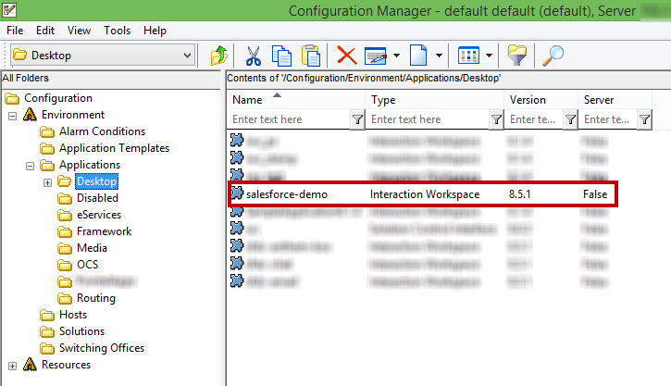

Figure . Create new application

Create the list of options. The configured sections will be visible to you in the CME.

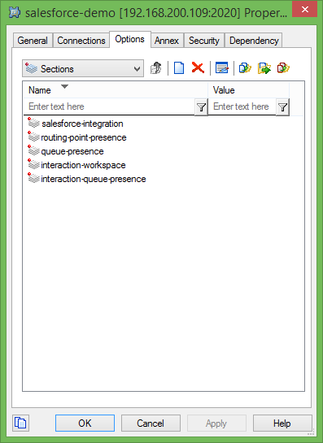

Figure . Configured sections

Add the relevant configuration options for all the media types (Voice, Email, and Chat) to the available sections.

|  |  |
| --- | --- |
| **Key Name** | object-name |
| **Valid Values** | Valid field ID’s from Salesforce object |
| **Default Value** | -- |

**Description**

Configure any valid Salesforce object name. The Adapter will pop the configured Salesforce object and create/update the activity log.

**Ex. object-name = Lead**

Lead is a valid SFDC object name and it will be used for search records and create activity logs in apex classes.

**Ex. Object-name = CustomLead__c**

Custom objects must be configured with a valid custom object name (API Name) so that records will be popped up and activity logs created.

|  |  |
| --- | --- |
| **Key Name** | object.url-id |
| **Valid Values** | Valid field ID’s from Salesforce object |
| **Default Value** | -- |

**Description**

Configure a valid URL ID of the custom Salesforce object. This option must be configured in order for the Adapter to popup the appropriate custom Salesforce object.

Section 4.1.5 will explain the details of obtaining a Salesforce custom object URL ID.

|  |  |
| --- | --- |
|  | Note: This key is only valid for custom object pop-ups and is not needed for default SFDC objects. |

**Ex. object.url.id = a02**

The following keys must be configured to pop-up records for emails in Salesforce.

|  |  |
| --- | --- |
| **Key Name** | email.max-record.open |
| **Valid Values** | 0-50 |
| **Default Value** | 5 |

**Description**

This option is used to set a limit for opening multiple matched records for a given search conditions. This option will be activated when the option **email.inb.search.multi-match=openall** or

**email.out.search.multi-match**=**openall** is set.

|  |  |
| --- | --- |
| **Key Name** | email.search.no-record.activity-log |
| **Valid Values** | true/false |
| **Default Value** | false |

**Description**

This configuration key specifies whether or not to create activity log and map to newly saved record when no record found for the specific search data.

|  |  |
| --- | --- |
| **Key Name** | email.new-record.field-id |
| **Valid Values** | Valid field ID’s from Salesforce object |
| **Default Value** | -- |

**Description**

This option prepopulates search values on Salesforce objects. This option should be configured when the option “email.inb.search.no-record” or “email.out.search.no-record” value is set to “**opennew**”. Section **4.1.5** will explain the details of finding the field ID details from the Salesforce object.

|  |  |
| --- | --- |
| **Key Name** | email.search.priority |
| **Valid Values** | user-data/attribute/both |
| **Default Value** | -- |

**Description**

This option specifies the search priority for email popup. Based on the configuration, the Adapter will get a search value from Genesys application.

* **user-data:** The Adapter will take search values configured in “**email.<email-type>.search.user-data.key-names**”.
* **attribute:** The Adapter will take search values configured in “**email.< email -type>.search.attribute.key-names**”.
* **both:** The Adapter will take search values configured in both “**email.< email -type>.search.user-data.key-names**” and “**email.< email -type>.search.attribute.key-names**”.

|  |  |
| --- | --- |
| **Key Name** | email.search.condition-type |
| **Valid Values** | AND/OR |
| **Default Value** | OR |

**Description**

This option specifies the search condition type.

* **AND**: The Adapter will search for records only if all search values match.
* **OR**: The Adapter will search for records if any one search value matches.

|  |  |
| --- | --- |
| **Key Name** | email.search.phone-number-format |
| **Valid Values** | Valid phone number format |
| **Default Value** | (xxx)xxx-xxxx,xxx-xxx-xxxx,(xxx)-xxx-xxxx,(xxx)xxxxxxx |

**Description**

The Adapter will search records in Salesforce using the configured search format, when no records are found in the search without applying any format. This option accepts more than one value separated by comma.

**Ex. sfdc.email.search.phone-number.format= (xxx) xxx-xxxx**

First, the Adapter will search records using the search data as it is. If no records are found, then it will apply the configured formats with the search data and perform the search again. The Soap API response time will vary based on the number of formats that will be searched.

|  |  |
| --- | --- |
|  | **Note:**  Use character 'x' to denote phone number digit and use any delimiter between numbers  e.g. : xxx-xxx-xxxx  (xxx)-xxx-xxxx  (xxx) xxx-xxxx  (xxx)xxxxxxx  If a format is not configured for this option, the above formats will be applied by default.  Each format takes a reasonable amount of time to get a response from the Salesforce server based on the server ability. |

### Inbound Email Configuration

This section provides configuration necessary for customizing salesforce application for email interaction.

|  |  |
| --- | --- |
| **Key Name** | email.inb.search.user-data.key-names |
| **Valid Values** | EmailAddress,FirstName,LastName, and any attached data key name |
| **Default Value** | -- |

**Description**

The Adapter searches records for inbound emails in Salesforce based on the values from the configured attach data keys. This option accepts one or more search values separated by a comma.

|  |  |
| --- | --- |
| **Key Name** | email.inb.search.attribute.key-names |
| **Valid Values** | to,from,cc,bcc,subject,frompersonal,mailbox |
| **Default Value** | to |

**Description**

The Adapter searches records for inbound emails in Salesforce based on the configured attribute keys. This option accepts one or more search values separated by a comma.

|  |  |
| --- | --- |
| **Key Name** | email.inb.popup-event-names |
| **Valid Values** | invite/pulled |
| **Default Value** | -- |

**Description**

Based on the value configured, Salesforce will pop up an appropriate email event.

* **invite**: The Adapter will pop up Salesforce objects on email ringing state. The agent will have the ability to view the customer information prior to replying the email.
* **pulled**: The Adapter will pop up Salesforce objects after an inbound/outbound email is pulled out from the workbin.

|  |  |
| --- | --- |
| **Key Name** | email.inb.create.activity-log |
| **Valid Values** | true/false |
| **Default Value** | false |

**Description**

This option determines whether or not the Salesforce Adapter will create activity logs for inbound email record popups.

|  |  |
| --- | --- |
| **Key Name** | email.inb.update.activity-log |
| **Valid Values** | true/false |
| **Default Value** | false |

**Description**

This option determines whether or not the Salesforce Adapter will update activity logs for inbound email record popups.

|  |  |
| --- | --- |
| **Key Name** | email.inb.update.activity-log.event-names |
| **Valid Values** | datachanged,markdone,movetoworkbin,rejected,reply |
| **Default Value** | -- |

**Description**

Based on this configuration, Salesforce will update activity logs and record data on an appropriate email event for inbound email. This option accepts multiple events configurations separated by comma.

* **released**: The Adapter updates the activity logs and new records in a email released event for inbound emails.
* **datachanged**: The Adapter updates the activity logs and new records in email Disposition code changed events for inbound emails.
* **rejected**: The Adapter updates the activity logs and new records when an inbound email is rejected.

|  |  |
| --- | --- |
| **Key Name** | email.inb.search.enable.profile-activity |
| **Valid Values** | true/false |
| **Default Value** | false |

**Description**

This option specifies whether to create profile level activity log when multi-match scenario found for inbound email. If Common Search enabled then adapter will use **“sfdc.profile-activity.business-attribute”** configuration to create activity log and if object based search enabled then adapter takes “**sfdc.create.activity.business-attribute”** configuration for creating log.

|  |  |
| --- | --- |
| **Key Name** | email.inb.search.multi-match |
| **Valid Values** | openall/searchpage/none |
| **Default Value** | searchpage |

**Description**

This option specifies the action to be taken when multiple records found for given inbound email search condition.

* **openall:** Configuring this value will open all records found for given search condition. Opening all records can be controlled by the option email.max-record.open. If email.max-record.open option is not configured adapter will take default value 50.
* **searchpage:** Configuring this value will list all records found for given search condition in search page.
* **none:** Configuring this value will not do any action for given search condition.

|  |  |
| --- | --- |
| **Key Name** | email.inb.search.no-record |
| **Valid Values** | Searchpage/createnew/none/opennew |
| **Default Value** | opennew |

**Description**

This option specifies the action to be taken when no record found for given inboundemail search condition. By default the option value is **opennew**.

* **opennew**: Configuring this value will open new record with search data pre-populated on appropriate fields based on the value configured in the option **email.new-record.field-id**.
* **searchpage**: Configuring this value will opens the search page based on the value configured in the option **email.multi-match.records.searchpage** configuration.
* **createnew**: Configuring this value will create new record with data. New record data fields should be configured in **sfdc.new-record.business-attribute** option.
* **none**: No action will happen when it is configured as none.

|  |  |
| --- | --- |
| **Key Name** | email.inb.search.no-record.enable.profile-activity |
| **Valid Values** | true/false |
| **Default Value** | false |

**Description**

This option specifies whether to create profile level activity log when no-match found scenario and no-match action is set to **“opennew”** for an inbound email. If Common Search option is enabled then adapter will use **“sfdc.profile-activity.business-attribute”** configuration to create activity log and if object based search enabled then adapter takes “**sfdc.create.activity.business-attribute”** configuration for creating log.

|  |  |
| --- | --- |
| **Key Name** | email.inb.search.no-record.popup.profile-activity |
| **Valid Values** | true/false |
| **Default Value** | false |

**Description**

This option specifies whether or not to pop-up user profile activity log which is created on no – match found scenario on inbound email.

|  |  |
| --- | --- |
| **Key Name** | email.inb.search.popup.profile-activity |
| **Valid Values** | true/false |
| **Default Value** | false |

**Description**

This option specifies whether or not to pop-up user profile activity log which is created on multiple match record found scenario on inbound email.

|  |  |
| --- | --- |
| **Key Name** | email.inb.search.no-record.none.activity-log |
| **Valid Values** | true/false |
| **Default Value** | false |

**Description**

This option specifies whether or not to create profile level activity log when no-match found scenario and no-match action is set to **“none”** for inbound email. If Common Search enabled then adapter will use **“sfdc.profile-activity.business-attribute”** configuration to create activity log and if object based search enabled then adapter takes “**sfdc.create.activity.business-attribute”** configuration for creating log.

### Outbound Email Configuration

In this section the outbound email configuration keys are provided.

|  |  |
| --- | --- |
| **Key Name** | email.out.search.user-data.key-names |
| **Valid Values** | EmailAddress,FirstName,LastName, and any attached data key name |
| **Default Value** | -- |

**Description**

The Adapter will search records in Salesforce for outbound emails based on the values from the configured attach data keys. This option accepts one or more search values separated by a comma.

|  |  |
| --- | --- |
| **Key Name** | email.out.search.attribute.key-names |
| **Valid Values** | to,from,cc,bcc,subject,frompersonal,mailbox |
| **Default Value** | to |

**Description**

The Adapter searches records in Salesforce for outbound emails based on the configured attribute keys. This option accepts one or more search values separated by a comma.

|  |  |
| --- | --- |
| **Key Name** | email.out.popup-event-names |
| **Valid Values** | create/pulled/send |
| **Default Value** | -- |

**Description**

This option is used to configure the time when Salesforce objects will pop up for outbound emails.

* **create**: The Adapter will pop-up Salesforce objects when you about to compose a outbound email from team communicator. The agent will have the option to view the customer information prior to answering the emails.
* **pulled**: The Adapter will pop up Salesforce objects after an inbound/outbound email pulled out from the workbin.
* **send**: The Adapter will pop up Salesforce objects after sending an outbound email.

|  |  |
| --- | --- |
| **Key Name** | email.out.success.create.activity-log |
| **Valid Values** | true/false |
| **Default Value** | false |

**Description**

This option specifies whether the Salesforce Adapter will create an activity log for outbound email records pop-up.

|  |  |
| --- | --- |
| **Key Name** | email.out.success.update.activity-log |
| **Valid Values** | true/false |
| **Default Value** | false |

**Description**

This option specifies whether the Salesforce Adapter will update activity logs for outbound records pop-up.

|  |  |
| --- | --- |
| **Key Name** | email.out.success.update.activity-log.event-names |
| **Valid Values** | send,datachanged,deleted,movetoworkbin |
| **Default Value** | -- |

**Description**

Based on the value configured, the Salesforce Adapter will update activity logs/custom object record data during an email event. More than one events configuration can be configured if separated by comma.

|  |  |
| --- | --- |
| **Key Name** | email.out.fail.create.activity-log |
| **Valid Values** | true/false |
| **Default Value** | true |

**Description**

This option specifies whether or not the Salesforce Adapter will create an activity log for outbound email failure record popups.

|  |  |
| --- | --- |
| **Key Name** | email.out.fail.create.activity-log.event-names |
| **Valid Values** | Send,datachanged,deleted,movetoworkbin |
| **Default Value** | -- |

**Description**

Based on the event names configured, Salesforce will pop up a record and create an activity log for the outbound failure scenario.

|  |  |
| --- | --- |
| **Key Name** | email.out.search.enable.profile-activity |
| **Valid Values** | true/false |
| **Default Value** | false |

**Description**

This option specifies whether to create profile level activity log when multi-match scenario found for outbound email. If Common Search enabled then adapter will use **“sfdc.profile-activity.business-attribute”** configuration to create activity log and if object based search enabled then adapter takes “**sfdc.create.activity.business-attribute”** configuration for creating log.

|  |  |
| --- | --- |
| **Key Name** | email.out.search.popup.profile-activity |
| **Valid Values** | true/false |
| **Default Value** | false |

**Description**

This option specifies whether or not to pop-up user profile activity log which is created on multi-match record found scenario on outbound email.

|  |  |
| --- | --- |
| **Key Name** | email.out.search.multi-match |
| **Valid Values** | searchpage/openall/none |
| **Default Value** | searchpage |

**Description**

This option specifies the action to be taken when multiple records found for given **outbound** email search condition.

* **openall**: Configuring this value will open all records found for given search condition. Opening all records can be controlled by the option **email.max-record.open**. If **email.max-record.open** option is not configured adapter will take default value 50.
* **searchpage**: Configuring this value will list all records found for given search condition in search page.
* **none**: Configuring this value will not do any action for given search condition

|  |  |
| --- | --- |
| **Key Name** | email.out.search.no-record |
| **Valid Values** | searchpage/createnew/none/opennew |
| **Default Value** | opennew |

**Description**

This option specifies whether to create profile level activity log when no-match found scenario and no-match action is set to **“none”** for outbound email. If Common Search enabled then adapter will use **“sfdc.profile-activity.business-attribute”** configuration to create activity log and if object based search enabled then adapter takes “**sfdc.create.activity.business-attribute”** configuration for creating log.

|  |  |
| --- | --- |
| **Key Name** | email.out.search.no-record.enable.profile-activity |
| **Valid Values** | true/false |
| **Default Value** | false |

**Description**

This option specifies whether to create profile level activity log when no-match found scenario and no-match action is set to **“opennew”** for outbound email. If Common Search enabled then adapter will use **“sfdc.profile-activity.business-attribute”** configuration to create activity log and if object based search enabled then adapter takes “**sfdc.create.activity.business-attribute”** configuration for creating log.

|  |  |
| --- | --- |
| **Key Name** | email.out.search.no-record.popup.profile-activity |
| **Valid Values** | true/false |
| **Default Value** | false |

**Description**

This option specifies whether or not to popup user profile activity log which is created on no-match found scenario on outbound email.

|  |  |
| --- | --- |
| **Key Name** | email.out.search.no-record.none.activity-log |
| **Valid Values** | true/false |
| **Default Value** | false |

**Description**

This option specifies whether to create profile level activity log when no-match found scenario and no-match action is set to **“none”** for outbound email. If Common Search enabled then adapter will use **“sfdc.profile-activity.business-attribute”** configuration to create activity log and if object based search enabled then adapter takes “**sfdc.create.activity.business-attribute”** configuration for creating log.

|  |  |
| --- | --- |
| **Key Name** | email.multi-match.records.searchpage |
| **Valid Values** | Any sfdc object name |
| **Default Value** | -- |

**Description**

This option defines the SFDC object name, in which the multiple records are searched and displayed.

|  |  |
| --- | --- |
| **Key Name** | email.append.activity-log.event-names |
| **Valid Values** | markdone,delete,movetoworkbin,send,reply |
| **Default Value** | -- |

**Description**

This option appends the activity logs and record data on an appropriate inbound/ consult chat event. This option accepts multiple events configurations separated by comma.

* **released**: The Adapter appends the activity logs in a chat released event for inbound chats.
* **markdone**: The salesforce adapter updates the activity logs and new records when an inbound chat is markdone.
* **delete:** The salesforce adapter updates the activity logs and new records when an inbound chat is deleted.
* **movetoworkbin:** The salesforce adapter appends the activity logs and new records when an inbound email is moved to Workbin.
* **send:** The salesforce adapter appends the activity logs when an inbound email is sent.
* **reply:** The salesforce adapter appends the activity logs when reply an inbound email.

## Configuring Salesforce – Chat Media Type

In this section the configuration keys relevant for configuring salesforce for chat interaction is given. The configuration keys are segregated under sections to make readers easily pinpoint the right configuration settings they need.

### Enable/Disable Common

Use the procedures for configuring chat media type.

|  |  |
| --- | --- |
| **Key Name** | sfdc.chat.enable.common.search |
| **Valid Values** | true/false |
| **Default Value** | false |

**Description**

This option specifies whether the Adapter will use common search keys or search keys from the object level. For example:

* If the Adapter is configured to popup 2 or more objects
* The search key is common to all objects

Enable this option and configure the following options in **salesforce-integration**. Now the Adapter will use a common search key to find records in all configured objects and provide a screen-pop accordingly.

* If the Adapter is configured to popup 2 or more objects
* A unique search key is configured for each object

Disable this option and do not configure following options in **salesforce-integration**. The Adapter will use the search key configured in each object and query Salesforce to perform a screen popup.

|  |  |
| --- | --- |
| **Key Name** | sfdc.chat.inb.popup-event-names |
| **Valid Values** | invite/established |
| **Default Value** | -- |

**Description**

This option is used to configure the time when Salesforce objects will pop up.

* **invite**: The Adapter will pop up Salesforce objects on the chat ringing state. The agent will have the ability to view the customer information prior to answering the chat.
* **established**: The Adapter will pop up Salesforce objects after an chat is answered by an agent.

|  |  |
| --- | --- |
| **Key Name** | sfdc.chat.inb.search.user-data.key-names |
| **Valid Values** | Valid Key names from attach data separated by comma |
| **Default Value** | -- |

**Description**

This option will search records for inbound chats in Salesforce based on the values configured. This option accepts one or more search values separated by a comma.

|  |  |
| --- | --- |
| **Key Name** | sfdc.chat.inb.search.attribute.key-names |
| **Valid Values** | ixnid,state,moved-to-queue-at,queue,subtype,media-type,received-time,submitted-time,submitted-by,subject,startdate,contactid,comments |
| **Default Value** | -- |

**Description**

This option will search records for inbound chats in Salesforce based on the configured attribute keys. This option accepts one or more search values separated by a comma.

|  |  |
| --- | --- |
| **Key Name** | sfdc.chat.search.priority |
| **Valid Values** | user-data/attribute/both |
| **Default Value** | -- |

**Description**

This option specifies the search priority for chat interaction record popups. Based on the configuration, the Adapter will read search values from the appropriate options.

|  |  |
| --- | --- |
| Key Name | sfdc.chat.con.popup-event-names |
| Valid Values | ringing/established/released |
| Default Value | -- |

**Description**

This option is used to configure when Salesforce objects will pop up for consult chats.

* **ringing**: The Adapter will pop up Salesforce objects on the chat ringing state. The agent will have the option to view the customer information prior to answering the chat.
* **established**: The Adapter will pop up Salesforce objects after the chat is answered by the agent.
* **released**: The Adapter will pop up Salesforce objects after the chat is released by the agent or customer.

|  |  |
| --- | --- |
| **Key Name** | sfdc.chat.con.search.user-data.key-names |
| **Valid Values** | Valid field ID’s from Salesforce object |
| **Default Value** | -- |

**Description**

This option searches records in Salesforce based on the value of the configured attach data key, pops up on the second agent’s screen (agent who received the consult chat) and writes an activity log (collects data from the inbound chat configuration in the business attribute).

|  |  |
| --- | --- |
| **Key Name** | sfdc.chat.con.search.attribute.key-names |
| **Valid Values** | ixnid,state,moved-to-queue-at,queue,subtype,media-type,received-time,submitted-time,submitted-by,subject,startdate,contactid,comments |
| **Default Value** | -- |

**Description**

This option searches records in Salesforce based on the value from the configured attach data key, pops up on the second agent’s screen (agent who received the consult chat) and writes an activity log (collects data from the inbound chat configuration in the business attribute).

|  |  |
| --- | --- |
| **Key Name** | sfdc.chat.search.condition-type |
| **Valid Values** | AND/OR |
| **Default Value** | OR |

**Description**

This option specifies the search condition type when more than one search data type has been configured.

* **AND**: The Adapter will search for records only if all search values match.
* **OR**: The Adapter will search for records if any one of the search values match.

|  |  |
| --- | --- |
| **Key Name** | sfdc.chat.enable.attach.activity-id |
| **Valid Values** | true/false |
| **Default Value** | false |

**Description**

This option specifies whether or not to attach activity id with both inbound/ consult chat interactions.

|  |  |
| --- | --- |
| **Key Name** | sfdc.chat.attach.activity-id.key-name |
| **Valid Values** | Any string value |
| **Default Value** | Activity_id |

**Description**

This option defines the activity log for the key name.

### Object Configuration

This section provides the options for Salesforce object level configuration which are used for customizing salesforce during chat interactions. Each Salesforce object is configured in a unique section in annex tab. An administrator can configure different search keys and popup behavior for each object.

|  |  |
| --- | --- |
|  | **Note:**  Create a section in the Annex tab using a Salesforce object name.  Ex: lead, account, contact, opportunity  To configure a custom object configure the section as shown below  EX: customobject_1 |

|  |  |
| --- | --- |
| **Key Name** | object-name |
| **Valid Values** | Lead/Account/Case/Contact/Opportunituy/Custom_Object |
| **Default Value** | -- |

**Description**

This configuration key specifies the Salesforce object name. These object names will pop-up in salesforce page.

|  |  |
| --- | --- |
| **Key Name** | object.url-id |
| **Valid Values** | Lead/Account/Case/Contact/Opportunity/Custom_Object |
| **Default Value** | -- |

**Description**

Configure a valid URL ID of the custom Salesforce object. This option must be configured in order for the Adapter to popup the appropriate custom Salesforce object. Section 4.1.5 will explain the details of obtaining a Salesforce custom object URL ID. Ex. **object.url.id = a02**. The following keys must be configured to pop-up records for chats in Salesforce

|  |  |
| --- | --- |
|  | Note: This key is only valid for custom object pop-ups and is not needed for default SFDC objects. |

### Inbound chat configuration

This section provides configuration necessary for customizing salesforce application for chat interaction.

|  |  |
| --- | --- |
| **Key Name** | chat.new-record.field-id |
| **Valid Values** | Valid field ID’s from Salesforce object |
| **Default Value** | -- |

**Description**

This option prepopulates search values on Salesforce objects. This option should be configured when the option “chat.inb.search.no-record” or “chat.out.search.no-record” value is set to “opennew”. Section 4.1.5 will explain the details of finding the field ID details from the Salesforce object.

|  |  |
| --- | --- |
| **Key Name** | chat.search.priority |
| **Valid Values** | user-data/attribute/both |
| **Default Value** | -- |

**Description**

This configuration option specifies the priority constraints for searching a salesforce object.

|  |  |
| --- | --- |
| **Key Name** | chat.inb.search.multi-match |
| **Valid Values** | searchpage/openall/none |
| **Default Value** | searchpage |

**Description**

This option specifies the action to be taken when multiple records found for given inbound chat search condition.

* **openall:** Configuring this value will open all records found for given search condition. Opening all records can be controlled by the option chat.max-record.open. If chat.max-record.open option is not configured adapter will take default value 50.
* **searchpage:** Configuring this value will list all records found for given search condition in search page.
* **none:** Configuring this value will not do any action for given search condition.

|  |  |
| --- | --- |
| **Key Name** | chat.con.search.multi-match |
| **Valid Values** | searchpage/openall/none |
| **Default Value** | searchpage |

**Description**

This option specifies the action to be taken when multiple records found for given **Consult** chat search condition. If this option not configured, value is taken from **chat.inb.search.multi-match** configuration.

* **openall**: Configuring this value will open all records found for given search condition. Opening all records can be controlled by the option **chat.max-record.open**. If **chat.max-record.open** option is not configured adapter will take default value 50.
* **searchpage**: Configuring this value will list all records found for given search condition in search page.
* **none**: Configuring this value will not do any action for given search condition.

|  |  |
| --- | --- |
| **Key Name** | chat.inb.search.no-record |
| **Valid Values** | opennew/createnew/searchpage/none |
| **Default Value** | opennew |

**Description**

This option specifies the action to be taken when no record found for given inboundchat search condition. By default the option value is **opennew**.

* **opennew**: Configuring this value will open new record with search data pre-populated on appropriate fields based on the value configured in the option **chat.new-record.field-id**.
* **searchpage**: Configuring this value will opens the search page based on the value configured in the option **chat.multi-match.records.searchpage** configuration.
* **createnew**: Configuring this value will create new record with data. New record data fields should be configured in **sfdc.new-record.business-attribute** option.
* **none**: No action will happen when it is configured as none.

|  |  |
| --- | --- |
| **Key Name** | chat.inb.search.no-record.enable.profile-activity |
| **Valid Values** | true/false |
| **Default Value** | false |

**Description**

This option specifies whether to create profile level activity log when no-match found scenario and no-match action is set to **“opennew”** for an inbound chat. If Common Search option is enabled then adapter will use **“sfdc.profile-activity.business-attribute”** configuration to create activity log and if object based search enabled then adapter takes “**sfdc.create.activity.business-attribute”** configuration for creating log.

|  |  |
| --- | --- |
| **Key Name** | chat.inb.search.no-record.popup.profile-activity |
| **Valid Values** | true/false |
| **Default Value** | false |

**Description**

This option specifies whether or not to pop-up user profile activity log which is created on no – match found scenario on inbound chat.

|  |  |
| --- | --- |
| **Key Name** | chat.inb.search.popup.profile-activity |
| **Valid Values** | true/false |
| **Default Value** | false |

**Description**

This option specifies whether or not to pop-up user profile activity log which is created on multiple match record found scenario on inbound chat.

|  |  |
| --- | --- |
| **Key Name** | chat.inb.search.no-record.none.activity-log |
| **Valid Values** | true/false |
| **Default Value** | false |

**Description**

This option specifies whether or not to create profile level activity log when no-match found scenario and no-match action is set to **“none”** for inbound chat. If Common Search enabled then adapter will use **“sfdc.profile-activity.business-attribute”** configuration to create activity log and if object based search enabled then adapter takes “**sfdc.create.activity.business-attribute”** configuration for creating log.

|  |  |
| --- | --- |
| **Key Name** | chat.con.search.no-record |
| **Valid Values** | opennew/createnew/searchpage/none |
| **Default Value** | opennew |

**Description**

This option specifies the action to be taken when no record found for given **consult** chat search condition. By default the option value is taken from **chat.inb.search.no-record** configuration.

* **opennew**: Configuring this value will open new record with search data pre-populated on appropriate fields based on the value configured in the option **chat.new-record.field-id**.
* **searchpage**: Configuring this value will opens the search page based on the value configured in the option **chat.multi-match.records.searchpage** configuration.
* **createnew**: Configuring this value will create new record with data. New record data fields should be configured in **sfdc.new-record.business-attribute** option.
* **none**: No action will happen when it is configured as none.

|  |  |
| --- | --- |
| **Key Name** | chat.new-record.field-id |
| **Valid Values** | Any valid field id |
| **Default Value** | -- |

**Description**

This option prepopulates search values on Salesforce objects. This option should be configured when the option “chat.inb.search.no-record” or “chat.out.search.no-record” value is set to “opennew”. Section 4.1.5 will explain the details of finding the field ID details from the Salesforce object.

|  |  |
| --- | --- |
| **Key Name** | chat.search.condition-type |
| **Valid Values** | AND/OR |
| **Default Value** | OR |

**Description**

This option specifies the search condition type.

* **AND**: The Adapter will search for records only if all search values match.
* **OR**: The Adapter will search for records if any one search value matches.

|  |  |
| --- | --- |
| **Key Name** | chat.inb.search.user-data.key-names |
| **Valid Values** | Valid field ID’s from Salesforce object |
| **Default Value** | -- |

**Description**

The Adapter searches records for inbound chats in Salesforce based on the values from the configured attach data keys. This option accepts one or more search values separated by a comma.

|  |  |
| --- | --- |
| **Key Name** | chat.inb.search.attribute.key-names |
| **Valid Values** | Valid field ID’s from Salesforce object |
| **Default Value** | -- |

**Description**

The Adapter searches records for inbound chats in Salesforce based on the configured attribute keys. This option accepts one or more search values separated by a comma.

|  |  |
| --- | --- |
| **Key Name** | chat.inb.popup-event-names |
| **Valid Values** | Invite/established |
| **Default Value** | -- |

**Description**

Based on the value configured, Salesforce will pop up an appropriate chat event.

* **invite:** The Adapter will pop up Salesforce objects on the chat ringing state. The agent will have the ability to view the customer information prior to answering the chat.
* **established:** The Adapter will popup Salesforce objects after the chat is answered by the agent.

|  |  |
| --- | --- |
| **Key Name** | chat.inb.create.activity-log |
| **Valid Values** | true/false |
| **Default Value** | true |

**Description**

This option determines whether or not the Salesforce Adapter will create activity logs for inbound chat record popups.

|  |  |
| --- | --- |
| **Key Name** | chat.inb.update.activity-log |
| **Valid Values** | true/false |
| **Default Value** | true |

**Description**

This option determines whether or not the Salesforce Adapter will update activity logs for inbound rec**o**rd pop ups.

|  |  |
| --- | --- |
| **Key Name** | chat.inb.update.activity-log.event-names |
| **Valid Values** | released/datachanged/markdone |
| **Default Value** | -- |

**Description**

Based on this configuration, Salesforce will update activity logs and record data on an appropriate chat event for inbound chat. This option accepts multiple events configurations separated by comma.

* **released**: The Adapter updates the activity logs and new records in a chat released event for inbound chats.
* **datachanged**: The Adapter updates the activity logs and new records in chat Disposition code changed events for inbound chats.
* **markdone**: The Adapter updates the activity logs and new records when an inbound chat is rejected.

|  |  |
| --- | --- |
| **Key Name** | chat.inb.search.enable.profile-activity |
| **Valid Values** | true/false |
| **Default Value** | true |

**Description**

This option specifies whether to create profile level activity log when multi-match scenario found for inbound chat. If Common Search enabled then adapter will use **“sfdc.profile-activity.business-attribute”** configuration to create activity log and if object based search enabled then adapter takes “**sfdc.create.activity.business-attribute”** configuration for creating log.

### Consult chat Configuration

In this section the consult chat configuration keys are provided.

|  |  |
| --- | --- |
| **Key Name** | chat.con.search.user-data.key-names |
| **Valid Values** | Valid field ID’s from Salesforce object |
| **Default Value** | -- |

**Description**

This option allows the Adapter to search records in Salesforce based on the value of the configured attach data key, pop up on the second agent’s screen (agent who received the consult chat) and write an activity log (collect data from the inbound chat configuration in the business attribute).

|  |  |
| --- | --- |
| **Key Name** | chat.con.search.attribute.key-names |
| **Valid Values** | ixnid,state,moved-to-queue-at,queue,subtype,media-type,received-time,submitted-time,submitted-by,subject,startdate,contactid,comments |
| **Default Value** | -- |

**Description**

This option allows the Adapter to search records in Salesforce based on the value of the configured attach data key, pop up on the second agent’s screen (agent who received the consult chat) and write an activity log (collect data from the inbound chat configuration in the business attribute).

|  |  |
| --- | --- |
| **Key Name** | chat.con.popup-event-names |
| **Valid Values** | Invite/established |
| **Default Value** | -- |

**Description**

This option is used to configure when Salesforce objects will pop up for consult chats.

* **invite:** The Adapter will pop up Salesforce objects on the chat ringing state. The agent will have the ability to view the customer information prior to answering the chat.
* **established:** The Adapter will popup Salesforce objects after the chat is answered by the agent.

|  |  |
| --- | --- |
| **Key Name** | chat.con.create.activity-log |
| **Valid Values** | true/false |
| **Default Value** | true |

**Description**

This option determines whether or not the Salesforce Adapter will create activity logs for consult chat record popups.

|  |  |
| --- | --- |
| **Key Name** | chat.con.update.activity-log |
| **Valid Values** | true/false |
| **Default Value** | true |

**Description**

This option determines whether or not the Salesforce Adapter will update activity logs for consult chat record pop ups.

|  |  |
| --- | --- |
| **Key Name** | chat.con.update.activity-log.event-names |
| **Valid Values** | released/datachanged/rejected |
| **Default Value** | -- |

**Description**

Based on this configuration, Salesforce will update activity logs and record data on an appropriate chat event for inbound chat. This option accepts multiple events configurations separated by comma.

* **released**: The Adapter updates the activity logs and new records in a chat released event for inbound chats.
* **datachanged**: The Adapter updates the activity logs and new records in chat Disposition code changed events for inbound chats.
* **rejected**: The Adapter updates the activity logs and new records when an inbound chat is rejected.

|  |  |
| --- | --- |
| **Key Name** | chat.max-record.open |
| **Valid Values** | 0-50 |
| **Default Value** | 5 |

**Description**

This option is used to set a limit for opening multiple matched records for a given search condition. This option will be activated when the option **chat.inb.search.multi-match=openall** or

**chat.out.search.multi-match=openall** is set.

|  |  |
| --- | --- |
| **Key Name** | chat.search.no-record.activity-log |
| **Valid Values** | true/false |
| **Default Value** | false |

**Description**

This configuration key specifies whether or not to create activity log and map to newly saved record when no record found for the specific search data.

|  |  |
| --- | --- |
| **Key Name** | chat.append.activity-log.event-names |
| **Valid Values** | markdone, delete, movetoworkbin, send, reply |
| **Default Value** | -- |

**Description**

This option appends the activity logs and record data on an appropriate inbound/ consult chat event. This option accepts multiple events configurations separated by comma.

* **released**: The Adapter appends the activity logs in a chat released event for inbound chats.
* **markdone**: The salesforce adapter updates the activity logs and new records when an inbound chat is markdone.
* **delete:** The salesforce adapter updates the activity logs and new records when an inbound chat is deleted.
* **movetoworkbin:** The salesforce adapter appends the activity logs and new records when an inbound email is moved to Workbin.
* **send:** The salesforce adapter appends the activity logs when an inbound email is sent.
* **reply:** The salesforce adapter appends the activity logs when reply an inbound email.

|  |  |
| --- | --- |
| **Key Name** | chat.con.search.enable.profile-activity |
| **Valid Values** | true/false |
| **Default Value** | false |

**Description**

This option specifies whether or not to create profile level activity log when multi-match scenario found for **consult** chat. If this option is not set, value is taken from **chat.inb.search.enable.profile-activity** configuration**.** If Common Search enabled then adapter will use **“sfdc.profile-activity.business-attribute”** configuration to create activity log and if object based search enabled then adapter takes “**sfdc.create.activity.business-attribute”** configuration for creating log.

|  |  |
| --- | --- |
| **Key Name** | chat.multi-match.records.searchpage |
| **Valid Values** | Any sfdc object name |
| **Default Value** | -- |

**Description**

This option defines the SFDC object name, in which the multiple records are searched and displayed.

|  |  |
| --- | --- |
| **Key Name** | chat.search.phone-number-format |
| **Valid Values** | Valid field ID’s from Salesforce object |
| **Default Value** | -- |

**Description**

The Adapter will search records in Salesforce using the configured search format if no records are found in the search without applying any format. This option accepts more than one value separated by comma.

**Ex. sfdc.chat.search.phone-number.format= (xxx) xxx-xxxx**

First, the Adapter will search records using the search data as it is. If no records are found, then it will apply the configured formats with the search data and perform the search again. The Soap API response time will vary based on the number of formats that will be searched.

|  |  |
| --- | --- |
|  | **Note:**  Use character 'x' to denote phone number digit and use any delimiter between numbers  e.g. : xxx-xxx-xxxx  (xxx)-xxx-xxxx  (xxx) xxx-xxxx  (xxx)xxxxxxx  If a format is not configured for this option, the above formats will be applied by default.  Each format takes a reasonable amount of time to get a response from the Salesforce server based on the server ability. |

|  |  |
| --- | --- |
| **Key Name** | chat.con.search.no-record.enable.profile-activity |
| **Valid Values** | true/false |
| **Default Value** | false |

**Description**

This option specifies whether to create profile level activity log when no-match found scenario and no-match action is set to **“opennew”** for outbound chat. If Common Search enabled then adapter will use **“sfdc.profile-activity.business-attribute”** configuration to create activity log and if object based search enabled then adapter takes “**sfdc.create.activity.business-attribute”** configuration for creating log.

|  |  |
| --- | --- |
| **Key Name** | chat.con.search.no-record.popup.profile-activity |
| **Valid Values** | true/false |
| **Default Value** | false |

**Description**

This option specifies whether or not to popup user profile activity log which is created on no-match found scenario on consult chat.

|  |  |
| --- | --- |
| **Key Name** | chat.con.search.popup.profile-activity |
| **Valid Values** | true/false |
| **Default Value** | false |

**Description**

This option specifies whether to popup user profile activity log which is created on multiple match record found scenario on consult chat.

|  |  |
| --- | --- |
| **Key Name** | chat.con.create.activity-log.event-names |
| **Valid Values** | true/false |
| **Default Value** | false |

**Description**

This option specifies whether to create profile level activity log when no-match found scenario and no-match action

## Activity Logs/ Records

The following details are used to enter activity logs for each inbound, outbound and consult interaction.

1. Create a business attribute and configure this name in the key **sfdc.create.activity.business-attribute**.Create an attribute name for each page. (ex., voice. lead, chat. lead, etc.).

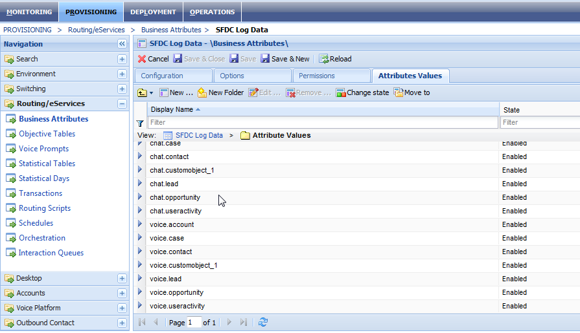

Figure . Attribute values

1. For each attribute name, create a unique section for default and custom fields.

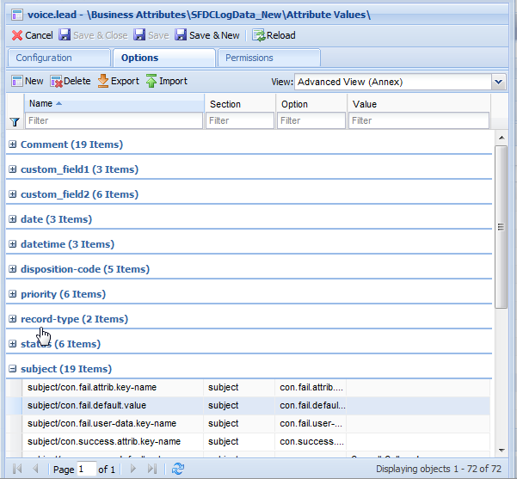

Figure . Attribute Names

Refer to the section 3.2 for configuring the values of each field for inbound, outbound and consult call scenarios.

### Configuring activity log in CME

The following steps guides you on how to configure the activity log in CME.

#### Business attribute configuration

The business attribute allows creating one or more attributes to acquire business process strategies. A business attribute folder contains various attributes values. You can configure each attributes with several CME objects. These objects determines the actions that are to be taken for maintaining business rules.

* + - 1. Open the **CME** and select **Configuration** >> **Resources** >> **Business** **Attributes.**

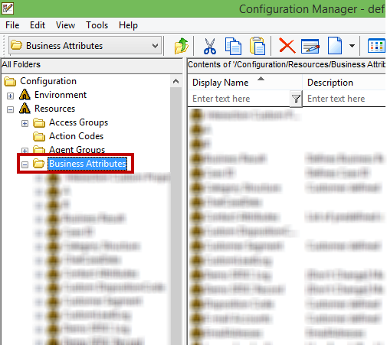

Figure . Business Attributes folder

* + - 1. Right-click the Business Attribute folder and then choose **New** >> **Business** **Attribute**

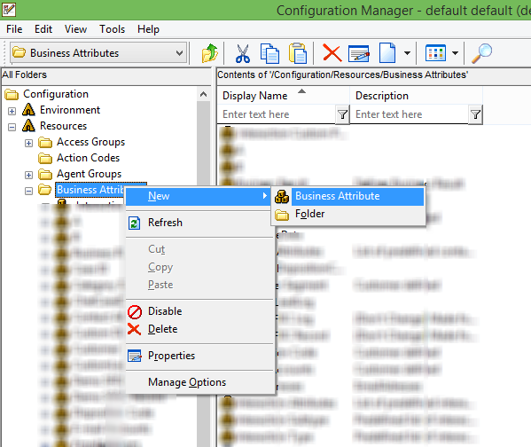

Figure . Select Business Attribute Option

* + - 1. The **New Business Attribute** window appears on the screen

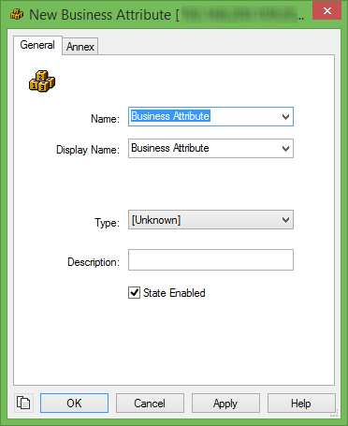

Figure . Create new business attribute

* + - 1. Enter the relevant attribute name and display name in Name and Display Name drop-down list box.

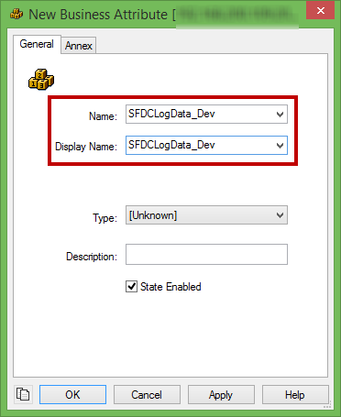

Figure . Name & Display Name for the new business attribute

* + - 1. Choose the business type as **Custom** from the **Type** drop-down list box as shown below.

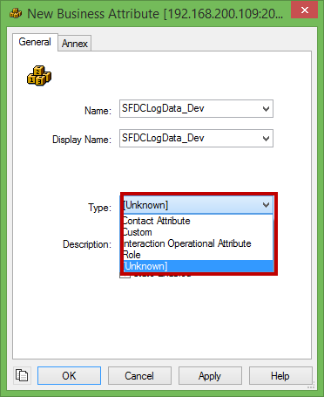

Figure . Select business attribute type

* + - 1. The following table describes the various options available in the Configuration screen.

|  |  |
| --- | --- |
| **Options** | **Description** |
| **OK** | Click **Ok** button to accept configuration changes. |
| **Cancel** | Click **Cancel** button cancel the configuration changes. |
| **Apply** | Click **Apply** button to apply changes. |
| **Help** | Click **Help** button to go to the help section. |

* + - 1. Click **Apply** button and then **OK** button.
      2. Once you click the **OK** button, the user can see the action code is listed in the window as shown below.

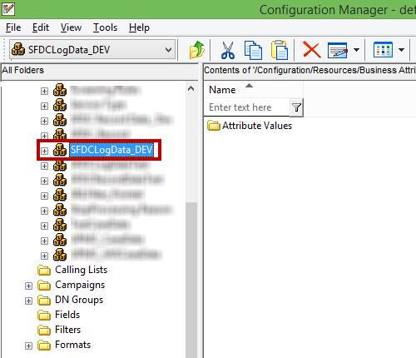

Figure . Newly created Business attribute

* + - 1. Expand the newly created business attribute tree (**SFDCLogData_DEV**). Right-click the **Attribute Values** folder and select **New>>Business Attribute Value**. Configure the attributes shown in figure below. The figure contains both the default and customized salesforce objects.

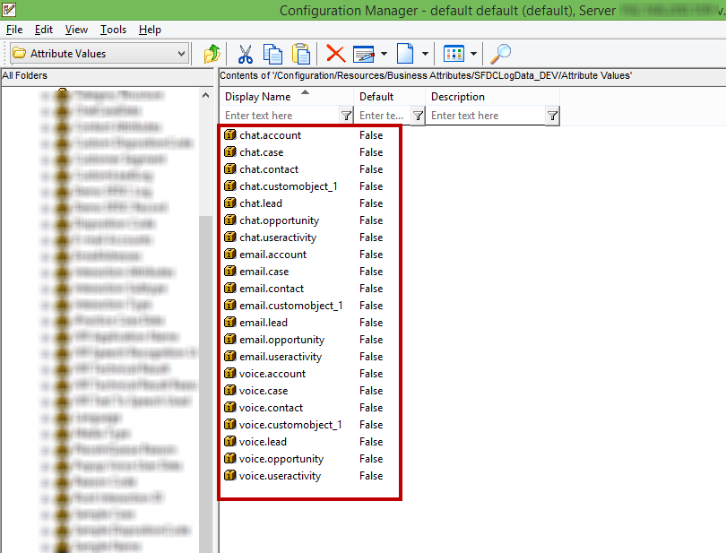

Figure . List of created attributes

* + - 1. Now, right-click the selected attribute and select **Properties**. Click **Annex** tab and configure your required options and values. The options and values determines the actions that are to taken for maintaining the business rules.

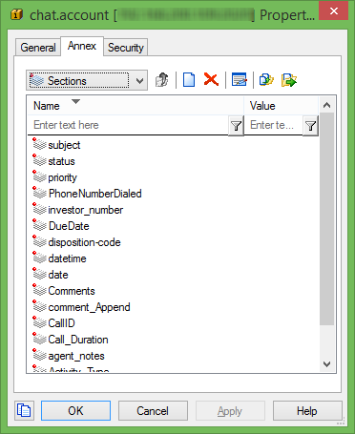

Figure . Annex Tab

### Create New Record

The following details are used to create new record for each inbound, outbound and consult interaction.

* + - 1. Create a business attribute and configure the following name in the key: **sfdc.new-record.business-attribute.** Create an attribute name for each page (ex., lead, contact, account, case, opportunity, customobject_1, etc.).

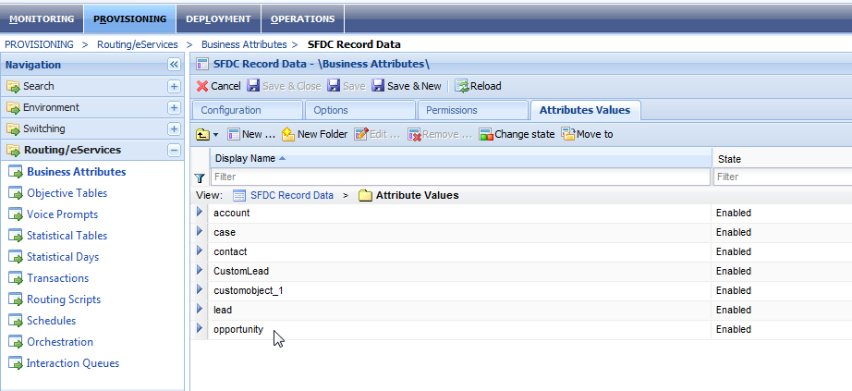

Figure . Create a new record

* + - 1. For each attribute name, create a unique section for default and custom fields.

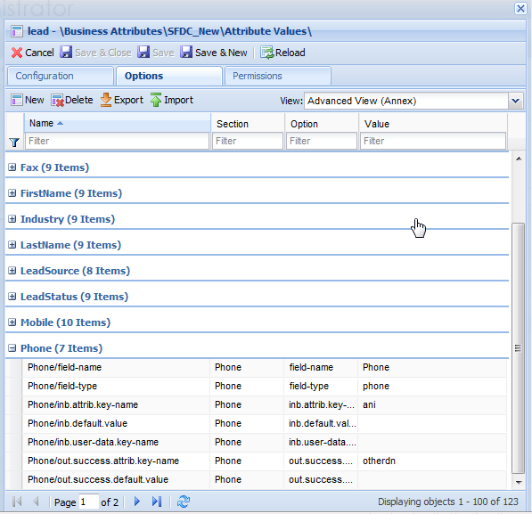

Figure . Create a unique section

* + - 1. Refer to Section 3.2 for configuring the values of each field for inbound, outbound and consult call scenarios.

### Common Configuration for Activity Log/Create New Record

The following keys are common for field entries.

|  |  |
| --- | --- |
| **Key Name** | field-name |
| **Valid Values** | Valid Field Name |
| **Default Value** | -- |

**Description**

This option specifies the field name from the Salesforce activity log record or object record to enter data from the Adapter.

|  |  |
| --- | --- |
| **Key Name** | field-type |
| **Valid Values** | RecordTypeId,text,number,dispositioncode,emailcontent,date,time,  datetime,date-timezone,duration,chatcontent,comments |
| **Default Value** | datetime |

**Description**

This option configures the value format for custom fields in the Activity log page. To update the field with the call duration, enable the following options: enable.update=true and set field-type=duration.

* **RecordTypeId**- This option enables the adapter to send
* **Datetime**-This enables the Adapter to send the current date and time from the agent’s local machine for creating activity logs or new records. Make sure that the option **“enable.time-stamp”** is configured as true, if the field type is configured as “**datetime**”.
* **text**-This option enables the Adapter to send valid string data to Salesforce based on the configuration provided in section 3.2.
* **date**-This option enables the Adapter to send the current date to Salesforce for creating activity logs or record with agent machine’s current date. Make sure that the option **“enable.time-stamp”** is configured as true, if the field type is configured as “**date**”.
* **time**-This option enables the Adapter to send the current time to Salesforce for creating activity logs or records with agent machine’s current time**.** Make sure that the option **“enable.time-stamp”** is configured as true, if the field type is configured as “**time**”.
* **duration**-This option enables the Adapter to send the current call duration for updating activity logs or records with the duration after the end of the call.
* **date-timezone** -This option enables the Adapter to send the current date and time with the configured time zone for creating or updating activity logs or new records with the date and time. Make sure that the option **“enable.time-stamp”** is configured as true, if the field type is configured as “**date-timezone**”.
* **number –** This option enables the adapter to send the contact number of the customer to salesforce for creating activity logs or records.
* **dispositioncode –** This option enables the adapter to send the disposition code of a callto salesforce for creating activity logs or records.
* **emailcontent –** This option enables the adapter to send the email content to salesforce for creating activity logs or records.
* **chatcontent –** This option enables the adapter to send the chat content to salesforce for creating activity logs or records.
* **comments –** This option enables the adapter to send the comments provided by agents about an interaction to salesforce for creating activity logs or records.

|  |  |
| --- | --- |
| **Key Name** | enable.time-stamp |
| **Valid Values** | true/false |
| **Default Value** | false |

**Description**

This option allows the Adapter to send the date and time to Salesforce when the **field-type** is configured as datetime, date, time and date-timezone.

If the **field-type** is set as “**text**”, it is optional to add date and time at the end of the default value, attached data value or attribute value from section **3.2** configuration.

|  |  |
| --- | --- |
| **Key Name** | enable.update |
| **Valid Values** | true/false |
| **Default Value** | false |

**Description**

This option allows the Adapter to update Salesforce record fields after an interaction has ended.

|  |  |
| --- | --- |
| **Key Name** | enable.append |
| **Valid Values** | true/false |
| **Default Value** | false |

**Description**

This option allows the adapter to append interaction datas with the salesforce records.

|  |  |
| --- | --- |
| **Key Name** | record-type.id |
| **Valid Values** | Valid record type ID. |
| **Default Value** | -- |

**Description**

Configuring this option allows the Adapter to create activity logs under custom activity record types.

### Inbound Activity Log/Create a New Record

The following keys are for inbound interaction activity field entries.

|  |  |
| --- | --- |
| **Key Name** | inb.default.value |
| **Valid Values** | Any string data |
| **Default Value** | -- |

**Description**

This option allows the Salesforce Adapter to populate preconfigured values in the appropriate fields of the activity log for inbound interactions.

|  |  |
| --- | --- |
| **Key Name** | inb.user-data.key-name |
| **Valid Values** | Valid attach data key name |
| **Default Value** | -- |

**Description**

This option allows the Salesforce Adapter to populate attached data values in the appropriate fields of the activity log for inbound interactions.

|  |  |
| --- | --- |
| **Key Name** | inb.attrib.key-name |
| **Valid Values** | ani/thisdn/otherdn/connid/agentid/dnis/calltype |
| **Default Value** | -- |

**Description**

This option allows the Salesforce Adapter to populate valid attribute key values in the appropriate fields of the activity log for inbound interactions.

|  |  |
| --- | --- |
|  | **Note:** The system will take any one of the above key values to enter data in the appropriate field. If all three keys are configured, the system will follow the priority levels noted below.   1. inb.user-data.key-name 2. inb.attrib.key-name 3. inb.default-value |

### Outbound Activity Log/Create a New Record

The following keys are used for successful outbound interaction activity field entries.

|  |  |
| --- | --- |
| **Key Name** | out.success.default.value |
| **Valid Values** | Any string data |
| **Default Value** | -- |

**Description**

This option allows the Salesforce Adapter to populate preconfigured values in the appropriate fields of the activity log for outbound interactions.

|  |  |
| --- | --- |
| **Key Name** | out.success.user-data.key-name |
| **Valid Values** | Valid Attach Data Key Name |
| **Default Value** | -- |

**Description**

This option allows the Salesforce Adapter to populate attached data values in the appropriate fields of the activity log for outbound interactions.

|  |  |
| --- | --- |
| **Key Name** | out.success.attrib.key-name |
| **Valid Values** | ani/thisdn/otherdn/connid/agentid/dnis/calltype |
| **Default Value** | -- |

**Description**

This option allows the Salesforce Adapter to populate valid attribute key values in the appropriate fields of the activity log for outbound interactions.

|  |  |
| --- | --- |
|  | **Note:** The system will take any one of the above key values to enter data in the appropriate field. If all three keys are configured, the system will follow the priority levels noted below.   1. out.success.user-data.key-name 2. out.success.attrib.key-name 3. out.success.default-value |

The following keys are for failure outbound interaction activity field entries.

|  |  |
| --- | --- |
| **Key Name** | out.fail.default.value |
| **Valid Values** | Any string data |
| **Default Value** | -- |

**Description**

This option allows the Salesforce Adapter to populate preconfigured default values in the appropriate fields of the activity log for outbound failure interactions.

|  |  |
| --- | --- |
| **Key Name** | out.fail.user-data.key-name |
| **Valid Values** | Valid attach data key name |
| **Default Value** | -- |

**Description**

This option allows the Salesforce Adapter to populate attach data values in the appropriate fields of the activity log for outbound failure interactions.

|  |  |
| --- | --- |
| **Key Name** | out.fail.attrib.key-name |
| **Valid Values** | ani/thisdn/otherdn/connid/agentid/dnis/calltype |
| **Default Value** | -- |

**Description**

This option allows the Salesforce Adapter to populate attribute key values in the appropriate fields of the activity log for outbound failure interactions.

|  |  |
| --- | --- |
|  | **Note:** The system will take any one of the above key values (failure scenario) to enter data in the appropriate field. If all three keys are configured, the system will follow the hierarchical level below.   1. out.fail.user-data.key-name 2. out.fail.attrib.key-name 3. out.fail.default-value |

### Consult Activity Log/Create a New Record

The following keys are used for successful outbound interaction activity field entries.

|  |  |
| --- | --- |
|  | **Note:** The system will consider inbound configurations if no consult values are found. |

|  |  |
| --- | --- |
| **Key Name** | con.user-data.key-name |
| **Valid Values** | Valid attach data key name |
| **Default Value** | -- |

**Description**

This option allows the Salesforce Adapter to populate attached data values in the appropriate fields of the activity log for consult interactions.

|  |  |
| --- | --- |
| **Key Name** | con.attrib.key-name |
| **Valid Values** | ani/thisdn/otherdn/connid/agentid/dnis/calltype |
| **Default Value** | -- |

**Description**

This option allows the Salesforce Adapter to populate valid attribute key values in the appropriate fields of the activity log for consult interactions.

|  |  |
| --- | --- |
| **Key Name** | con.default.value |
| **Valid Values** | Any string data |
| **Default Value** | -- |

**Description**

This option allows the Salesforce Adapter to populate pre-configured values in the appropriate fields of the activity log for consult interactions.

|  |  |
| --- | --- |
|  | **Note:** The system will take any one of the above key values to enter data in the appropriate field. If all three keys are configured, the system will follow the priority levels noted below.  1) con.user-data.key-name  2) con.attrib.key-name  3) con.default-value |

## Time Zone Configuration in Salesforce

This section provides time zone configuration details which need to be set up in the Salesforce Time Zone preferences. The table below provides the format for different time zones.

| **Format** | **Time Zone** |
| --- | --- |
| **GMT+14:00** | Line Is. Time (Pacific/Kiritimati) |
| **GMT+13:45** | Chatham Daylight Time (Pacific/Chatham) |
| **GMT+13:00** | New Zealand Daylight Time (Pacific/Auckland) |
| Phoenix Is. Time (Pacific/Enderbury) |
| Fiji Summer Time (Pacific/Fiji) |
| Tonga Time (Pacific/Tongatapu) |
| **GMT+12:00** | Petropavlovsk-Kamchatski Time (Asia/Kamchatka) |
| **GMT+11:00** | Lord Howe Daylight Time (Australia/Lord_Howe) |
| Australian Eastern Daylight Time (New South Wales)  (Australia/Sydney) |
| Solomon Is. Time (Pacific/Guadalcanal) |
| Norfolk Time (Pacific/Norfolk) |
| **GMT+10:30** | Australian Central Daylight Time (South Australia)  (Australia/Adelaide) |
| **GMT+10:00** | Australian Eastern Standard Time (Queensland)  (Australia/Brisbane) |
| **GMT+09:30** | Australian Central Standard Time (Northern  Territory) (Australia/Darwin) |
| **GMT+09:00** | Korea Standard Time (Asia/Seoul) |
| Japan Standard Time (Asia/Tokyo) |
| **GMT+08:00** | Hong Kong Time (Asia/Hong_Kong) |
| Malaysia Time (Asia/Kuala_Lumpur) |
| Philippines Time (Asia/Manila) |
| China Standard Time (Asia/Shanghai) |
| Singapore Time (Asia/Singapore) |
| China Standard Time (Asia/Taipei) |
| Australian Western Standard Time (Australia/Perth) |
| **GMT+07:00** | Indochina Time (Asia/Bangkok) |
| Indochina Time (Asia/Ho_Chi_Minh) |
| West Indonesia Time (Asia/Jakarta) |
| **GMT+06:30** | Myanmar Time (Asia/Rangoon) |
| **GMT+06:00** | Bangladesh Time (Asia/Dhaka) |
| **GMT+05:45** | Nepal Time (Asia/Kathmandu) |
| **GMT+05:30** | India Standard Time (Asia/Colombo) |
| India Standard Time (Asia/Kolkata) |
| **GMT+05:00** | Pakistan Time (Asia/Karachi) |
| Uzbekistan Time (Asia/Tashkent) |
| Yekaterinburg Time (Asia/Yekaterinburg) |
| **GMT+04:30** | Afghanistan Time (Asia/Kabul) |
| **GMT+04:00** | Azerbaijan Time (Asia/Baku) |
| Gulf Standard Time (Asia/Dubai) |
| Georgia Time (Asia/Tbilisi) |
| Armenia Time (Asia/Yerevan) |
| **GMT+03:30** | Iran Standard Time (Asia/Tehran) |
| **GMT+03:00** | Eastern African Time (Africa/Nairobi) |
| Arabia Standard Time (Asia/Baghdad) |
| Arabia Standard Time (Asia/Kuwait) |
| Arabia Standard Time (Asia/Riyadh) |
| Moscow Standard Time (Europe/Minsk) |
| Moscow Standard Time (Europe/Moscow) |
| **GMT+02:00** | Eastern European Time (Africa/Cairo) |
| South Africa Standard Time (Africa/Johannesburg) |
| Eastern European Time (Asia/Beirut) |
| Israel Standard Time (Asia/Jerusalem) |
| Eastern European Time (Europe/Athens) |
| Eastern European Time (Europe/Bucharest) |
| Eastern European Time (Europe/Helsinki) |
| Eastern European Time (Europe/Istanbul) |
| **GMT+01:00** | Central European Time (Africa/Algiers) |
| Central European Time (Europe/Amsterdam) |
| Central European Time (Europe/Berlin) |
| Central European Time (Europe/Brussels) |
| Central European Time (Europe/Paris) |
| Central European Time (Europe/Prague) |
| Central European Time (Europe/Rome) |
| **GMT+00:00** | Western European Time (Africa/Casablanca) |
| Greenwich Mean Time (Europe/Dublin) |
| Western European Time (Europe/Lisbon) |
| Greenwich Mean Time (Europe/London) |
| Greenwich Mean Time (GMT) |
| **GMT-01:00** | Eastern Greenland Time (America/Scoresbysund) |
| Azores Time (Atlantic/Azores) |
| Cape Verde Time (Atlantic/Cape_Verde) |
| **GMT-02:00** | Brasilia Summer Time (America/Sao_Paulo) |
| South Georgia Standard Time (Atlantic/South_Georgia) |
| Chile Time (America/Santiago) |
| **GMT-03:30** | Newfoundland Standard Time (America/St_Johns) |
| **GMT-04:00** | Atlantic Standard Time (America/Halifax) |
| Atlantic Standard Time (America/Puerto_Rico) |
| Atlantic Standard Time (Atlantic/Bermuda) |
| **GMT-04:30** | Venezuela Time (America/Caracas) |
| **GMT-05:00** | Colombia Time (America/Bogota) |
| Eastern Standard Time (America/Indiana/Indianapolis) |
| Peru Time (America/Lima) |
| Eastern Standard Time (America/New_York) |
| Eastern Standard Time (America/Panama) |
| **GMT-06:00** | Central Standard Time (America/Chicago) |
| Central Standard Time (America/El_Salvador) |
| Central Standard Time (America/Mexico_City) |
| **GMT-07:00** | Mountain Standard Time (America/Denver) |
| Mountain Standard Time (America/Mazatlan) |
| Mountain Standard Time (America/Phoenix) |
| **GMT-08:00** | Pacific Standard Time (America/Los_Angeles) |
| Pacific Standard Time (America/Tijuana) |
| Pitcairn Standard Time (Pacific/Pitcairn) |
| **GMT-09:00** | Alaska Standard Time (America/Anchorage) |
| Gambier Time (Pacific/Gambier) |
| **GMT-09:30** | Marquesas Time (Pacific/Marquesas) |
| **GMT-10:00** | Hawaii-Aleutian Standard Time (America/Adak) |
| Hawaii-Aleutian Standard Time (Pacific/Honolulu) |
| **GMT-11:00** | Niue Time (Pacific/Niue) |
| Samoa Standard Time (Pacific/Pago_Pago) |

# Miscellaneous

## Miscellaneous

### Internet Explorer

The following steps explain how to configure IE settings for the Salesforce-WDE integration.

* + - 1. Go to **Internet Explorer**->**Tools**--> and then choose **Internet options**.

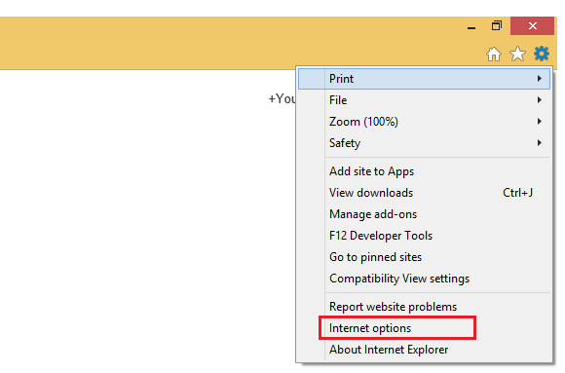

Figure . Internet options

1. Click on the **Security** tab.

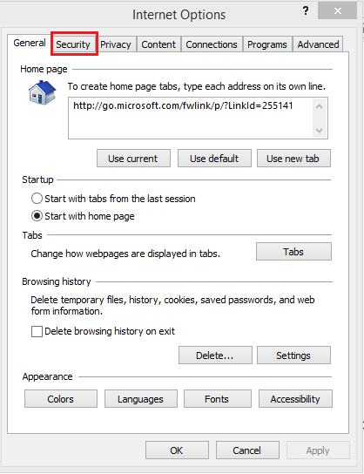

Figure . Security Tab

1. Click on the **Trusted sites** icon.

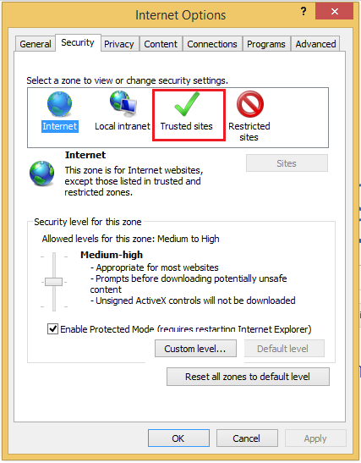

Figure . Trusted sites

1. Click the on **Sites** button and the **Trusted Sites** pop-up will appear.

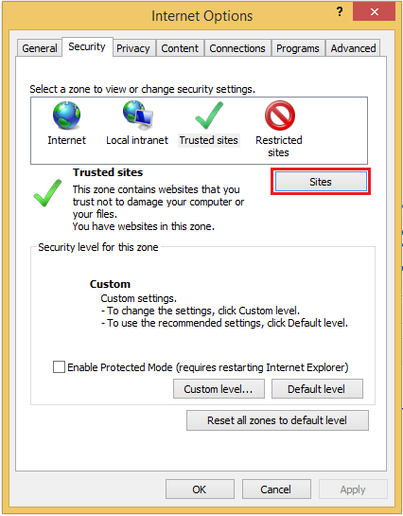

Figure . Sites

1. In the **Trusted sites** window, enter the site URL in the **Add this website to the zone** text box.

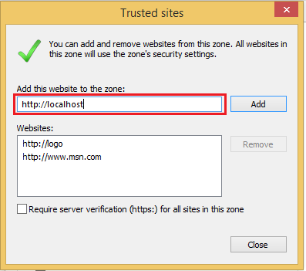

Figure . Website URL

1. Click on the **Add** button.
2. Uncheck the **Require Server Verification** option.

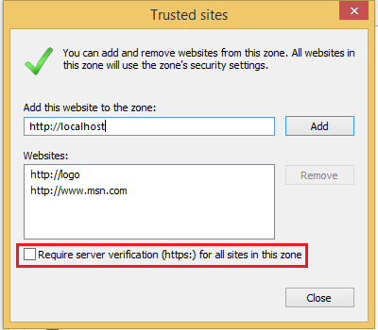

Figure . Uncheck the checkbox

1. Click on the **Close** button.
2. Click on the **Custom** **Level** button in Security Tab.

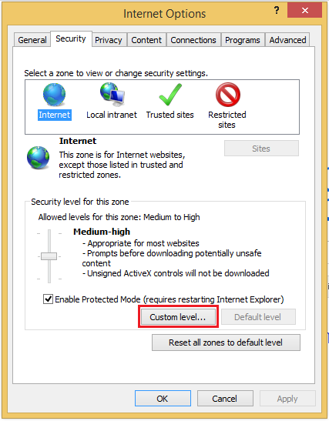

Figure . Custom level

1. Scroll about halfway down to the “**Miscellaneous”** heading (denoted by a **blank** **page** icon).

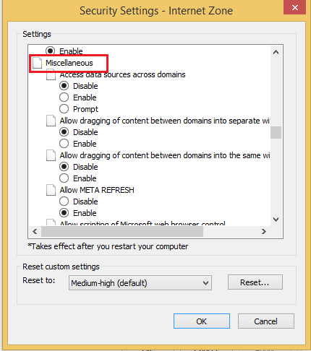

Figure . Miscellaneous Option

1. Under this heading is the option **Display Mixed Content**; set this to “**Enable**”.

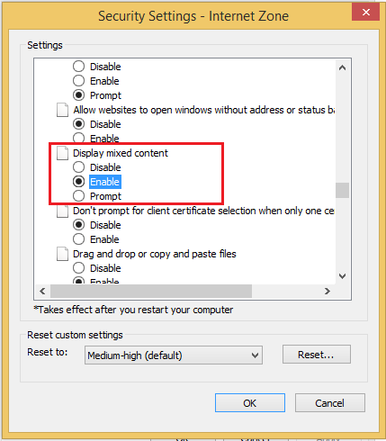

Figure . Enable Option

1. Click on the **OK** button, then the **Yes** button when prompted to confirm the change. Click the **OK** button to close the Options window.

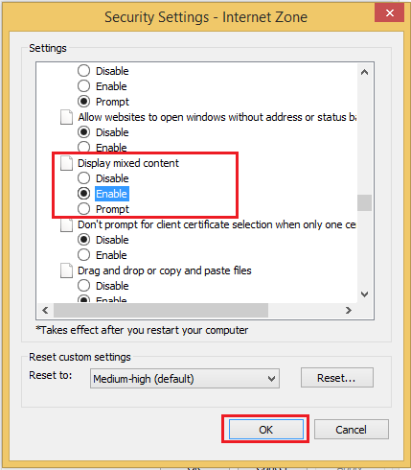

Figure . OK button

1. Close and restart the browser.

### Identify the Record Type for Activity History Log

If the Salesforce environment has been configured with multiple record types for the activity history and the SFDC Adapter has been configured to write activity logs for specific record types, the following steps can be used to identify the record ID for a specific record type.

* + - 1. Under the **Customize** menu, click on **Activities** and select **Task** **Record** **Types**.

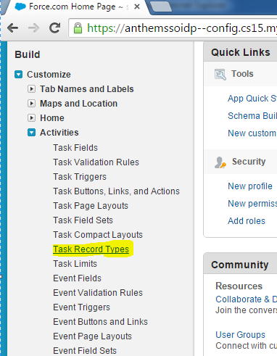

Figure . Activity Record Types

* + - 1. Click any one of the task record types from the list. The screenshot below shows the **Inbound/Outbound Call Activity** record type for reference.

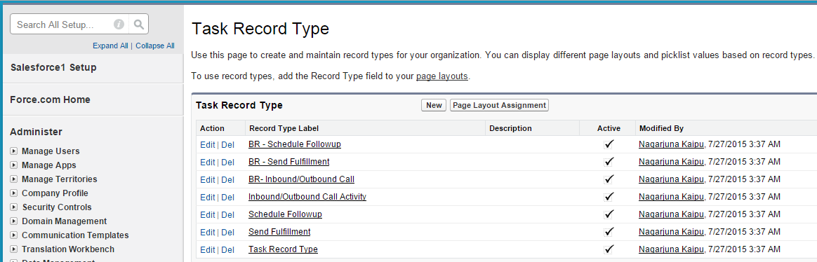

Figure . Activity Record Types

* + - 1. Configure the highlighted value (in picture 4.6) in the business attribute with a unique section.

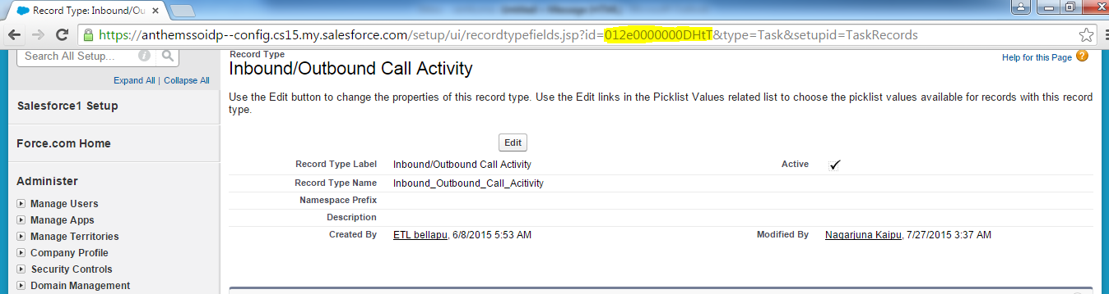

Figure . Activity Record ID

* Create a section under **lead** attribute (refer to section 3.1.2 for instructions on creating a section).
* Configure the following keys:
* field-name=RecordTypeId
* record-type.id=(copy the highlighted value)
* Save the changes.

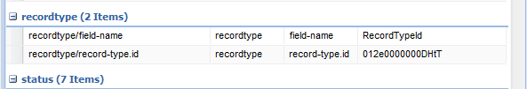

Figure . Record ID configuration in Business Attributes

### Create an Apex Class

When creating an Apex Class in Salesforce, the SFDC Adapter package will provide two classes to be imported into Salesforce. These class files will perform a record search in Salesforce.

1. Under the **Develop** menu, Click on **Apex** **Classes** and click **New** to create a new class.

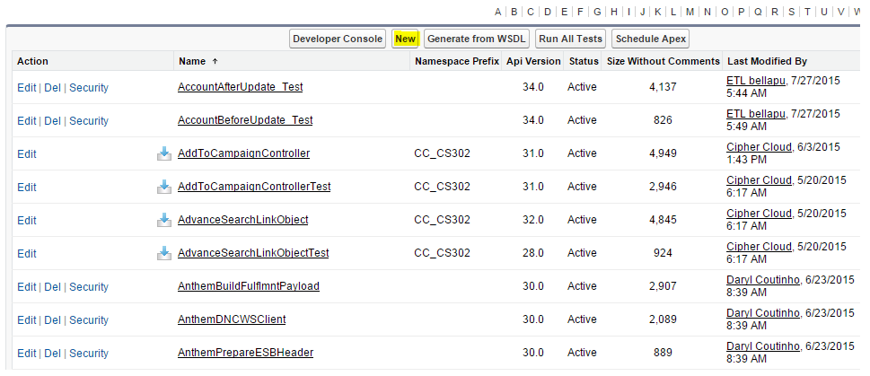

Figure . New Apex Class

1. Copy the code from the package (SFDCSearchObject.txt) and save it.
2. Copy the code from the package (SFDCSearchObject_Test.txt) and save it.
3. Open **SFDCSearchObject_Test** class and then click **Run Test**.

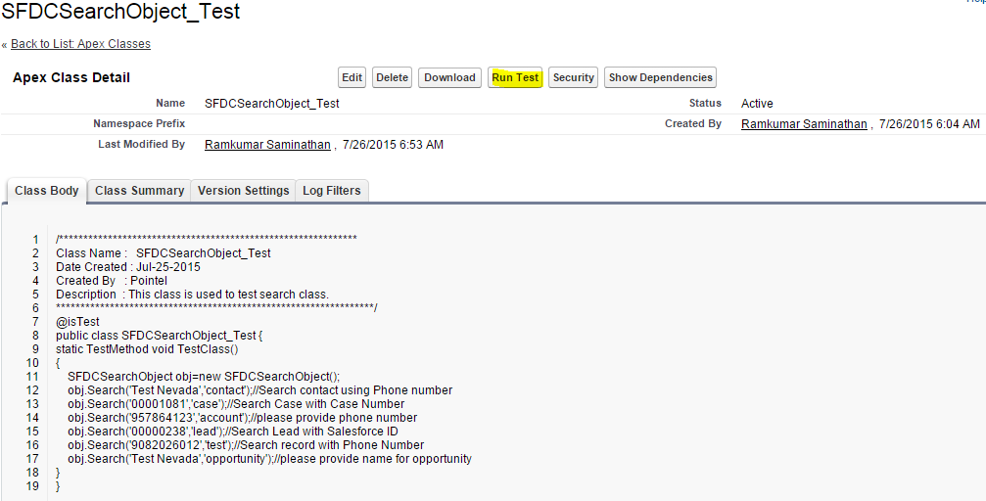

Figure . Run Test Apex Class

1. The **Apex Test Execution** view will display the test status as shown below.

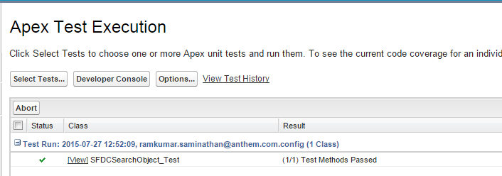

Figure . Apex Class Test Execution Status

1. Now, open the **SFDCSearchObject** class and check for **Code Coverage**. It should display 100% to make sure the class file is safe to run in the production Salesforce environment.

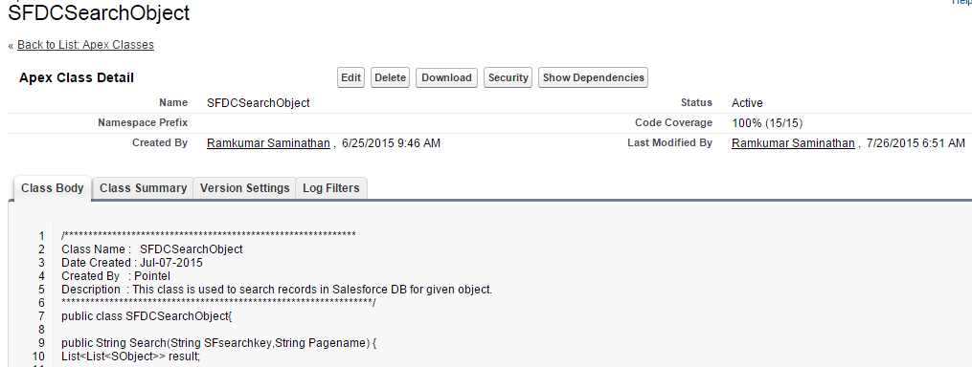

Figure . Apex Class Test Status

### Obtaining Salesforce Custom Object ID

* + - 1. After logging into Salesforce.com, click on the Service dropdown list located in the top right hand corner of the page.

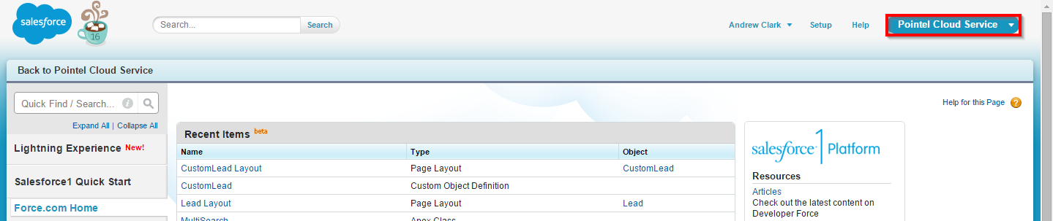

Figure . Service Dropdown List Box

* + - 1. The list of services pops up. Select **Sales** from the list.

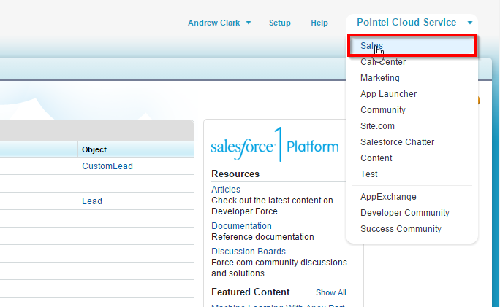

Figure . Select Service

* + - 1. The following objects are displayed in the Salesforce menu bar.

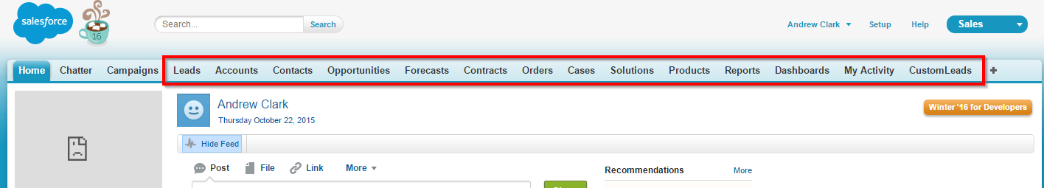

Figure . Salesforce objects

* + - 1. Click the object for which you want to obtain the object ID.

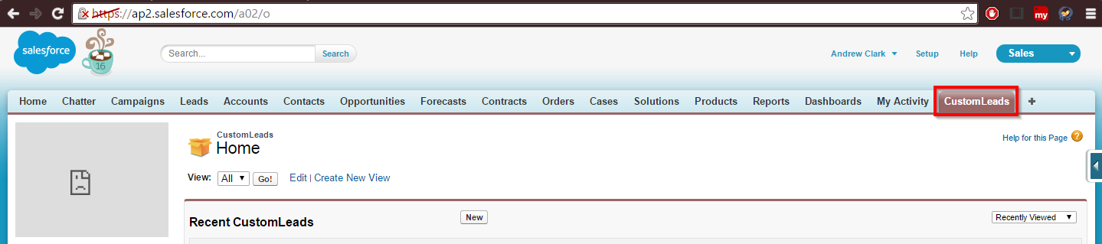

Figure . Choose Object

* + - 1. The object ID will be displayed in the address bar.

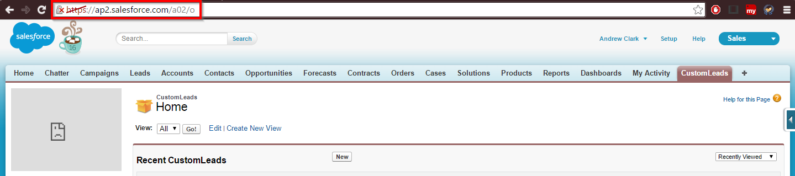

Figure . URL with Object ID

* + - 1. The “a02” in the address bar depicts the selected object ID. Configure the highlighted value in the following option:

**object.url-id=a02**

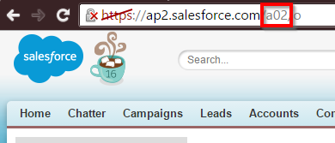

Figure . Object ID

### Obtaining the Salesforce Object Field ID

* + 1. After logging into **Salesforce.com**, click on the **Pointel Cloud Service** and then select the preferred Salesforce object.

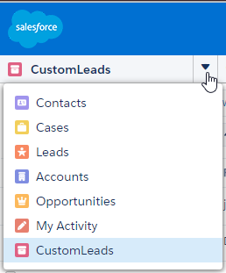

Figure . Custom leads

* + 1. Click on the **Edit** button in the record page.

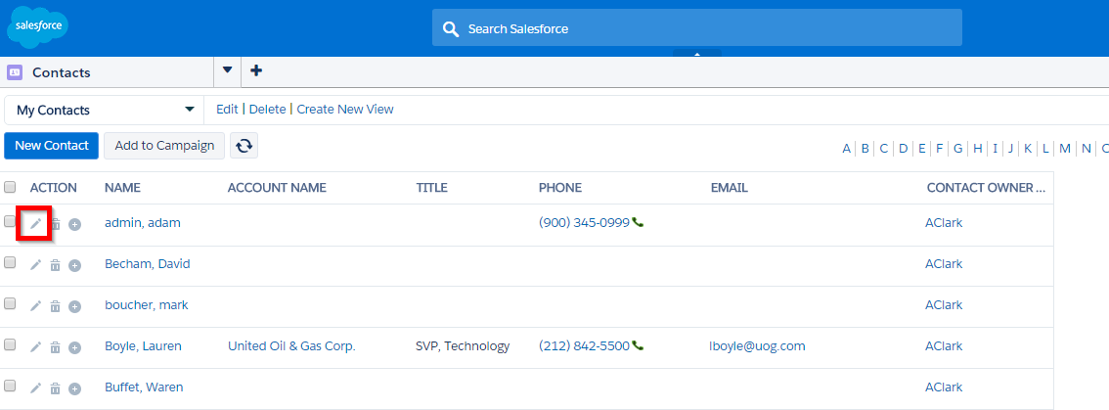

Figure . Edit Button

* + 1. Right-click on any of the text edit boxes and then choose **Inspect element**.

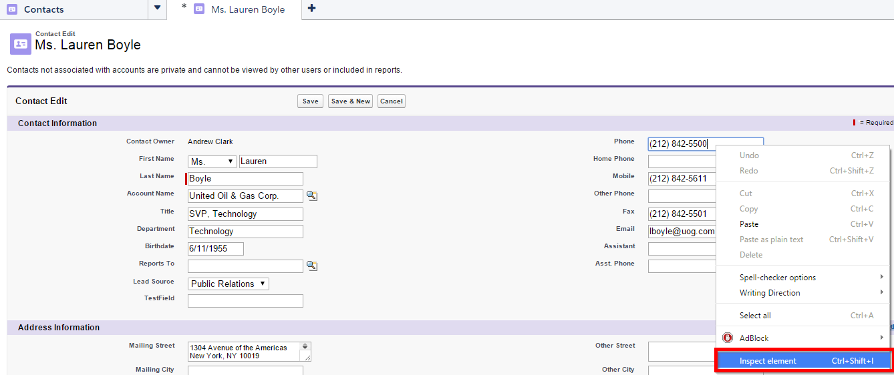

Figure . Inspect element

* + 1. You can obtain field ID from the XML code as shown below,

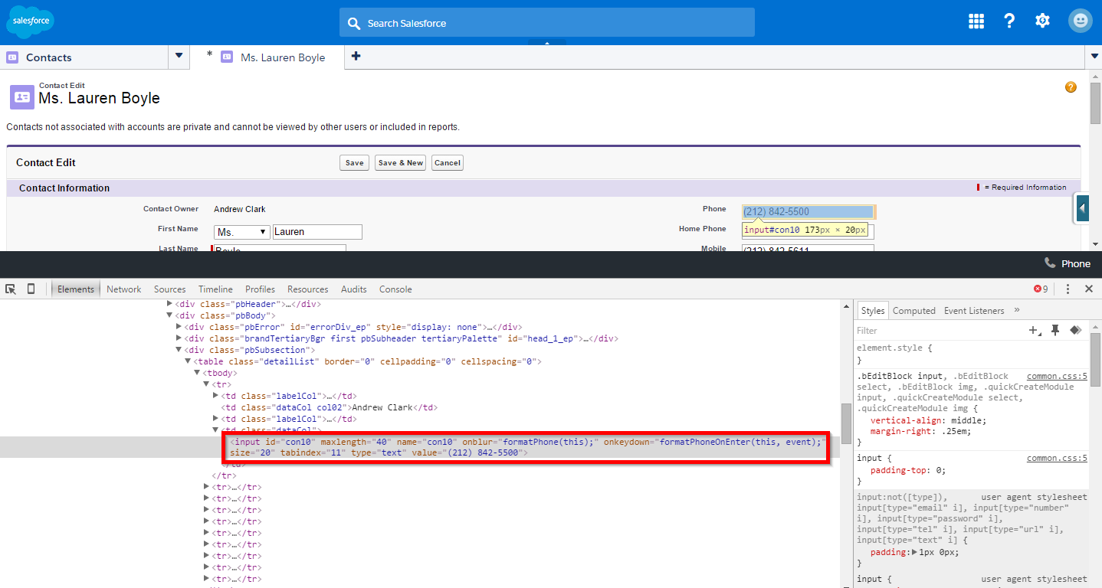

Figure . XML Code

* + 1. The figure below is the magnified area of the code. In this part of the code, **Con10** is the field ID.

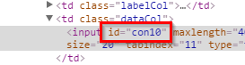

Figure . Magnified area

# Troubleshooting

## Troubleshooting

This section includes solutions for some of the issues which could be encountered during deployment.

### No Screen Popup

* Verify the installation process was completed successfully (section 2.2 explains the files required to integrate Salesforce with iWS/WDE).
* Verify the shield button is disabled if the end user is using the Google Chrome browser for the screen pop (section 4.1.2 explains how to disable the shield button in Chrome).
* Clear the browser cache if no screen pop occurs.

### SFDC Connection Status

The SFDC connection status will be displayed in the tool bar. One of the following two states will be displayed in the WDE tool bar.

* + 1. Connected Status

|  |  |
| --- | --- |
|  | **Note:**   * Clicking the green (or red if there is no connectivity) SFDC button in WDE will launch the browser with the Salesforce login. * The popup message will disappear in 10 second (default). This timer value is configurable. |

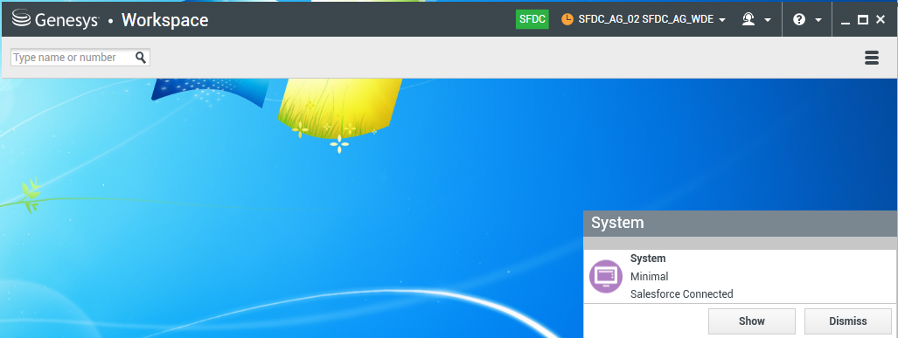

Figure . Connected Status Screen

* + 1. Disconnected Status

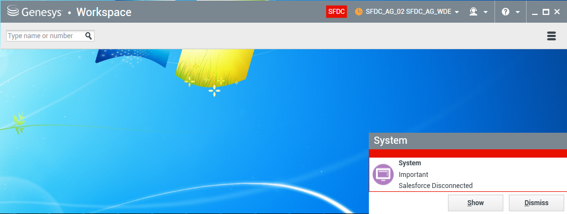

Figure . Disconnected Status Screen

A list of scenarios describing when a SFDC disconnected status could be received from WDE are noted below.

**Disconnect Scenario 1**

The screenshot below shows the disconnected status screen which appears when the agent has logged into WDE and logged into Salesforce (browser launched by WDE).

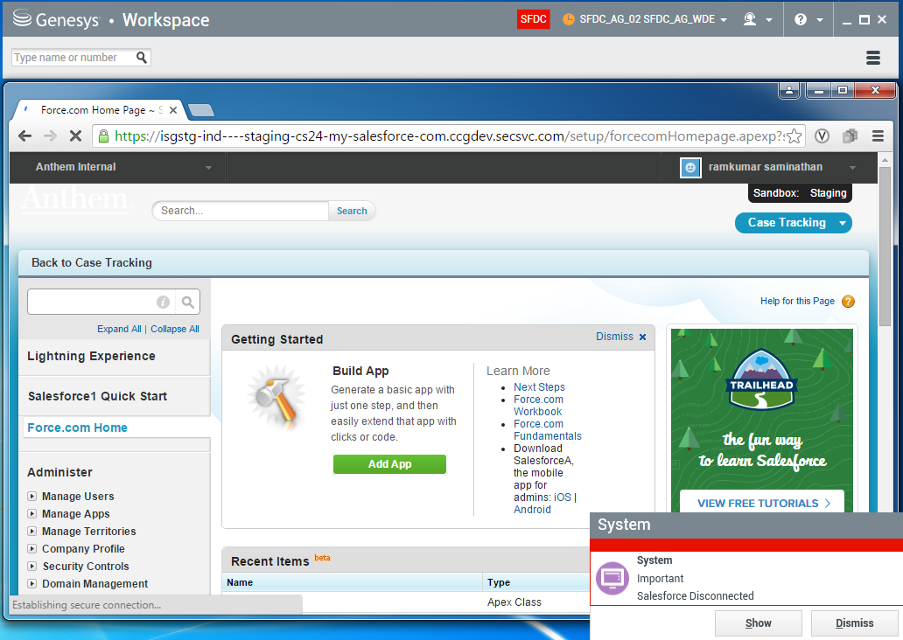

Figure . Disconnected Status Screen – Agent logged into WDE and logged into Salesforce

Here, the SFDC status on WDE shows disconnected. A SFDC connection with WDE will only be established when the agent clicks on the console application (e.g., “Case Tracking” for Broker Service and “Pointel Cloud Service” for Telesales).

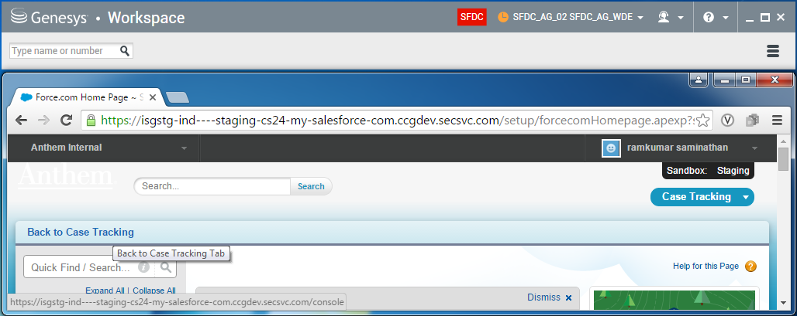

Figure . Case Tracking Console

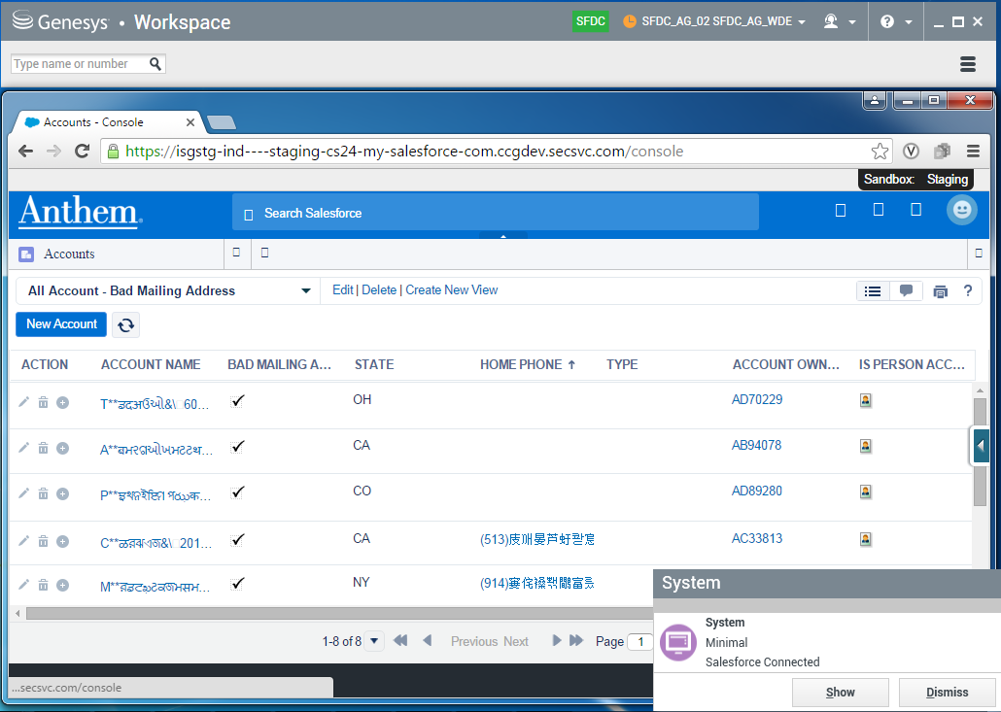

Figure . Pointel Cloud Service Console

**Disconnect Scenario 2**

If the Salesforce browser (launched by WDE) is closed and WDE remains on, WDE will lose access with SFDC and display the following status on the WDE tool bar.



Figure . Salesforce Browser Closed with WDE on

**Disconnect Scenario 3**

If the agent logs out of Salesforce (launched by WDE) and leaves WDE on, WDE will lose access with SFDC and display the following status on the WDE tool bar.

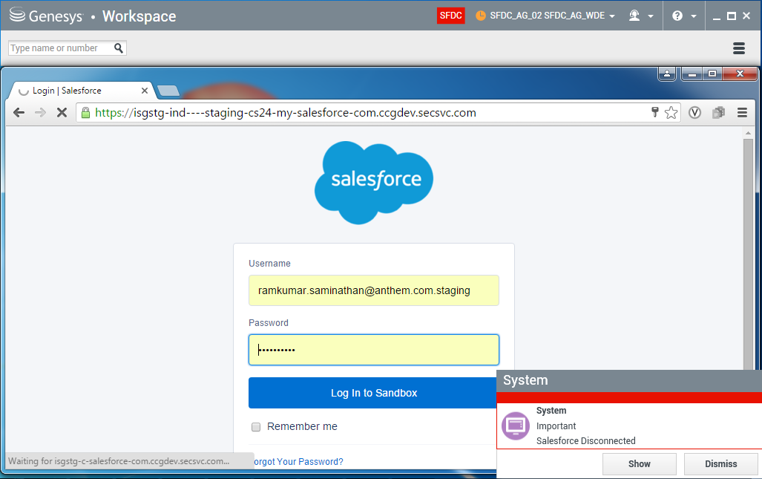

Figure . Agent Logs Out of Salesforce with WDE on

**Disconnect Scenario 4**

If the agent is logged out of Salesforce due to a session timeout (session timeout in Salesforce), WDE will lose access with SFDC and display the following status on the WDE tool bar.



Figure . Salesforce Session Timeout

**Disconnect Scenario 5**

If the agent refreshes the Salesforce browser (launched by WDE) by hitting “F5” or clicking the “refresh” button in the browser (screenshot below) in the middle of any call process or while WDE is still on, WDE will lose access with SFDC and display the following status on the WDE tool bar.

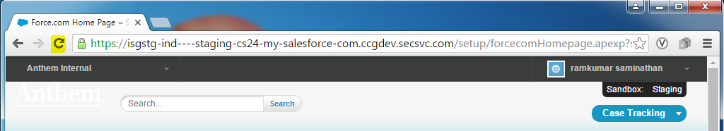

Figure . Refresh Button in the Salesforce Browser

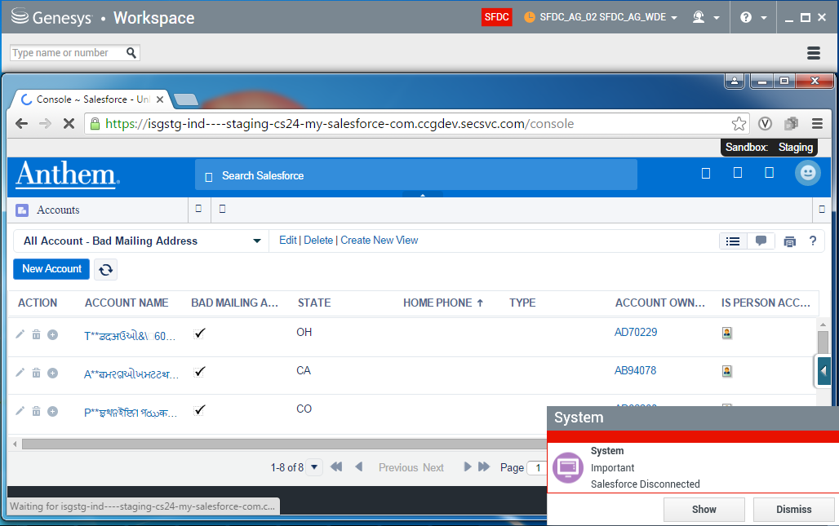

Figure . WDE Disconnected Status Screen

If the agent refreshes the browser again using either the refresh button or by hitting F5, WDE will reconnect with SFDC and display the following status on the WDE tool bar.

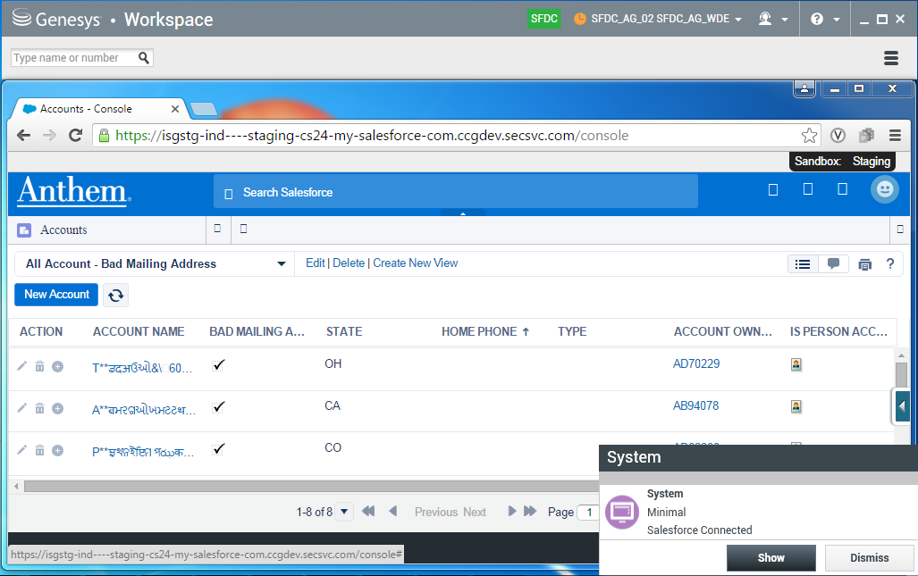

Figure . WDE-SFDC Reconnected after Second Browser Refresh